## Course Overview

* 1. 5 (one point five) Early Care and Education Clock Hours
* Audience: Early Childhood Educators

Course Description

This training will help you gain skills in understanding the importance of authentic assessment and how you can use the information you gather in a variety of ways.  This training does not focus on a specific assessment tool but gives you a solid background in assessment so that you can use the tools you already have or choose a tool in the future.   
  
When you return to the workplace you will be able to explore the assessment tool that is used in your workplace, practice strategies learned to gather more information about children, and apply assessment in lesson planning.  
  
Satisfactory completion of an application activity will be required before receiving completion credit.

Course Facilitator

**Sally Dannenberg**

[sally.dannenberg@uky.edu](mailto:sally.dannenberg@uky.edu)

Outcomes

Training Outcome

1. Brainstorm and plan strategies for making assessment part of the daily routine.
2. Identify a process for choosing an assessment (if you have that option) or using an assessment (if you already have an assessment system in place).
3. Incorporate assessment data in lesson planning.

Workplace Outcomes

1. Explore the assessment tool that is used in your workplace
2. Practice strategies learned to gather more information about children.
3. Apply assessment in lesson planning.

## Course at a Glance

|  |  |  |
| --- | --- | --- |
|  | **Lesson** | **Goals / Materials** |
| 1 | Welcome | Introduction to the course objectives and course facilitator.   * Materials: Course Handout |
| 2 | Debrief | Review of Authentic Assessment for Early Childhood: An Introduction   * Check Your Knowledge – Strategies for Collecting Observations |
| 3 | Assessments | Components of High Quality Assessment  Using Assessments in Early Childhood  Common Assessment Systems  Reliability |
| 4 | Lesson Planning Using Assessment Data | Assessment Cycle  Planning Questions to Consider  Using the KYECS  Individualizing Using Assessment Data  Lesson Planning – Putting it all Together  Individualizing Instruction for a Class  Universal Design for Learning |
| 5 | Application Activity | Complete Lesson Plan Based on Assessment Data |
| 6 | Course Wrap Up | Complete Course Evaluation, ECE-TRIS record and access certificate of completion. |

## Other Resources and Technology Requirements

Technology with ability to view videos and access resources listed.

## Policies and Expectations

Special Accommodations:Students who seek special accommodations due to a disability should contact us upon signing up for the course, or discovering the need for accommodations, and we will work to provide appropriate accommodations in a timely manner.

Credit will be entered into ECE-TRIS within 10 calendar days of successful completion of the training session.

Expectations:

* Take notes and use resources in the course as you complete activities and assignments. Just make sure all work is your own. When using resources to provide answers, put the responses in your own words.
* Do not copy answers from anyone else. If identical responses are found you may be requested to redo work before being assigned credit for the course.
* All course content and assignments must be completed satisfactorily to receive credit for this training session. You may be asked to provide follow up information or complete assignments again to complete the training session.

## Important Definitions for this Course

1. What did you see/notice about the child you were observing?
2. What were you hoping to learn?
3. What did you learn?
4. What developmental domains were represented?
5. What information from your observation would you share with a parent?
6. In looking at the Kentucky Early Childhood Standards, what did you learn about this child?
7. What challenges did you encounter?

## Strategies for Collecting Observations

1. Which method did you use for your observation in Authentic Assessment: An Introduction?
2. Which method would you like to try from the list?
3. Other observation strategies that you have seen used that you might try.

## Assessments

An early childhood assessment is a process of gathering information about a child, reviewing the information, and then using the information to plan educational activities that are at a level the child can understand and is able to learn from. For this series of modules, we are focusing on classroom/instructional assessment.

## Components of High Quality Assessment

There are several critical steps in designing this component of your continuous assessment system. First, programs must plan to gather information for all the major developmental domains or dimensions of development. The National Education Goals Panel (Kagan, Moore, & Bredekamp, 1995) identified five critical dimensions:

* Physical well-being and motor development
* Social and emotional development
* Approaches toward learning
* Language development
* Cognitive and general knowledge

Your program may call the learning domains by different names, but all need to be included in your continuous assessment system. Even if your early childhood program emphasizes one or two developmental areas more than others, research demonstrates that the domains interact to affect learning

[Kentucky Early Childhood Standards](https://kyecac.ky.gov/professionals/Early-Childhood-Standards/Getting-Started/Pages/Start-Here.aspx)

## Document with solid fillCommon Assessment Systems

[Kentucky Early Childhood Continuous Assessment Guide](https://www.kedsonline.org/Libraries/General/The_Kentucky_Early_Childhood_Continuous_Assessment_Guide.sflb.ashx)

## Assessment Cycle

**Observe and Assess**

Observe the children using your assessment tool.

**Analyze and Reflect**

After observing and assessing children it is important to reflect on the information before planning.

**Plan**

As you are working on your lesson planning, it is helpful to review recent assessment data for each child and ask yourself these questions:

* What are some strengths?
* What interests do I see? Are there any classroom areas they love or avoid?
* What developmental progress have I noticed?
* What next steps will support this child?

**Implement**

After planning and creating lesson plans is complete you will implement the planned activities.

**Analyze and Reflect**

After implementation you need to reflect on what worked, what did not work, and any changes to make before starting again.

## Document with solid fillUsing the KYECS

[Kentucky Early Childhood Standards – Using the Standards](https://kyecac.ky.gov/professionals/Early-Childhood-Standards/Getting-Started/Pages/Using-the-Standards.aspx)

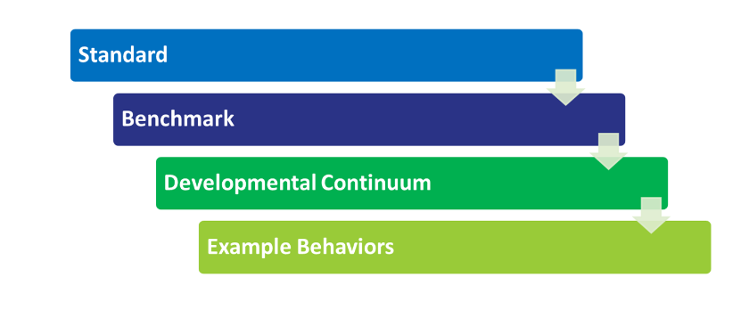**Standard** – A general statement that represents the information, skills, and/or characteristics that a child should demonstrate at the end of the age span covered.

**Benchmark** – A concept or skill that is a subset of what is addressed within the standard. Put another way, Benchmarks collectively describe the specific skills, knowledge or characteristics included within a standard. Benchmarks are not listed in any specific order, either in importance or in a developmental order.

**Developmental Continuum** – A predictable but not rigid sequence of accomplishments which describe the progressive levels of performance in the order in which they emerge in most children, based on current research. Developmental Continuum items describe how skills related to a Benchmark typically emerge or progress.

**Example Behaviors** – Observable “samples” of what children might do as they demonstrate accomplishments at each level of the Developmental Continuum, but not a definitive list of how a child might demonstrate a specific accomplishment or an exhaustive inventory.

The Developmental Continuum and Example Behaviors help educators identify skills most likely to occur next in the continuum and provide examples of what skills or knowledge a child might demonstrate at specific ages. These illustrations are useful to adults as they seek to understand and plan learning experiences to facilitate children’s development.

## Lesson Planning – Putting it All Together



[Video - Lesson Planning Using Assessments](https://vimeo.com/766571558/42b1c74a05?embedded=true&source=video_title&owner=171488698)

## Universal Design for Learning

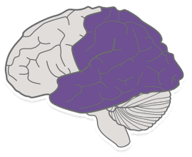**Representation:** UDL recommends offering information in more than one format. Providing text, audio, video and hands-on learning gives all kids a chance to access the material in whichever way is best suited to their learning strengths.

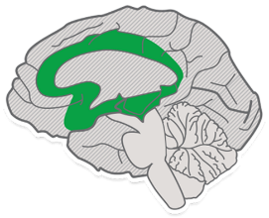

**Engagement:** UDL encourages teachers to look for multiple ways to motivate students. Letting kids make choices and providing activities that feel relevant to their lives are some examples of how teachers can sustain students’ interest. Other common strategies include making skill building feel like a game and creating opportunities for students to get up and move around the classroom.

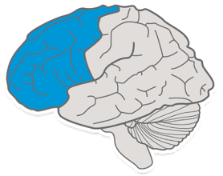

**Action and expression:** UDL suggests giving kids more than one way to interact with the material and to show what they’ve learned. Some children may prefer telling you about the building they built with the blocks, others may want to show you.

[Universal Design for Learning Guidelines](https://www.hdilearning.org/wp-content/uploads/2022/11/UDL-Graphic-CAST.pdf)

[The UDL Guidelines](https://udlguidelines.cast.org/)

## Application Activity

Using your observation notes from the focus child, create three activities you will do or additions to the classroom, to support learning goals for that child. Activities or materials should be written on a lesson plan format that includes areas for children’s development or interest (play) areas. Notes will also need to be included on the lesson plan about what you will be doing with the child, how you will support their play, etc. Notes should be directly related to the child’s needs and the observation you completed of the child.

[Infant Toddler Lesson Plan](https://www.childcareawareky.org/wp-content/uploads/2019/09/Section-4-Infants-and-Toddlers-15-Infant-toddler-weekly-lessons-plans.pdf)

[Preschool Lesson Plan](https://www.childcareawareky.org/wp-content/uploads/2019/09/Section-5-Preschool-Classroom-2-Weekly-lesson-plan.pdf)

Reminder: Your Application Activity will be graded withing 3 working days. Upon successful completion of the activity and all course components, credit will be entered into ECE-TRIS within 10 calendar days.