[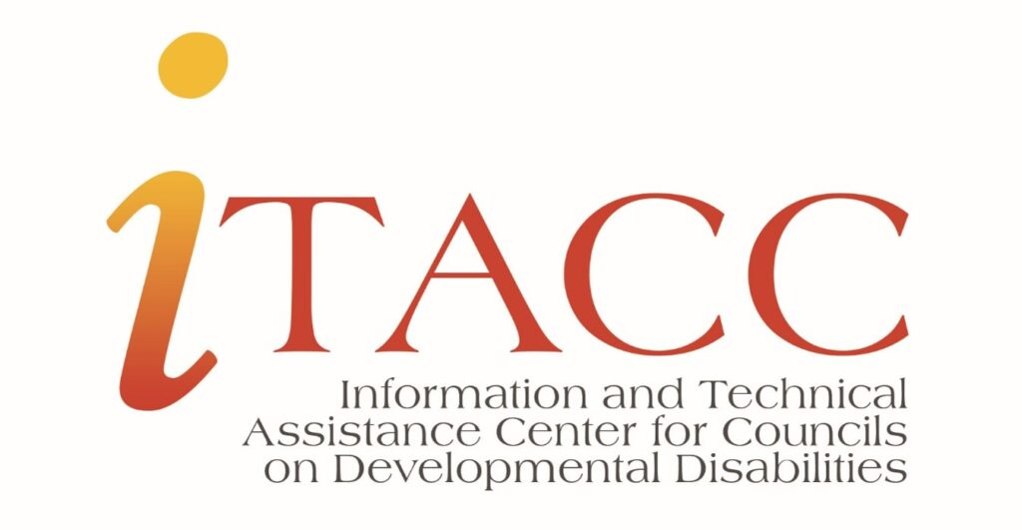](https://www.hdilearning.org/wp-content/uploads/2022/02/iTACC-Logo.jpg)

**Course Overview: Welcome! This course provides general information regarding financial requirements for the Council.**

**We will focus on the following:**

* How councils are funded
* Formula Grant
* Notice of Award
* OGM (Office of Grants Management)
* Funding Statutes and Regulations
* Federal Financial Reports

**Course Objectives:**

In this course, you will:

1.) Identify where Council funding comes from and how it is awarded.

2.) Demonstrate knowledge of regulations and requirements needed to receive funding.

**Who Funds the Councils?**

* Congress approves Developmental Disabilities Council funding through the appropriation process.
* Funds are in the Department of Health and Human Services and the Administration for Community Living budgets.



Step 1:

**The White House Office of Management & Budget (OMB) coordinates with federal agencies to create the President’s Budget, which covers all federal agencies. The President submits the Budget to Congress, which** **must pass appropriations legislation that funds federal agencies.**



Step **2:**

**The Congressional appropriations committees consider the President’s Budget as they prepare appropriations legislation for the next fiscal year.**



**Step 3:**

**The appropriations committees finalize the proposals and the House and Senate consider the legislation. Once passed and placed into a unified bill, Congress sends the legislation to the President.**



**Step 4:**

**The President signs the appropriations bill into law, providing funding for federal agencies.**

## **What is a Formula Grant?**

Council funding is based on a Formula Grant.

There are three statutory factors for determining each state’s funding amount. These factors are:

* Total population of the state/territory
* Need for services for people with DD in the state/territory
* Financial need of the state/territory

**State/ Territory Population (30%):**

Based on July Census figures released in August of each year.

**Need for Services (30%):**

Based on a 1.58 percent prevalence rate for developmental disabilities in each State and Territory from the HHS National Health Interview Survey on Disability (NHIS-D).

**Financial Need (40%):**

Use a combination of poverty (20%) and unemployment rates (20%) from July of each calendar year.

**Financial Need (40%):**

Use a combination of poverty (20%) and unemployment rates (20%) from July of each calendar year.

**How are funds allocated?**

* The authorizing legislation and regulations contain distribution formulas for allocating federal funds to states/territories or local governments.
* The eligibility criteria for the program are pre-determined. To receive a formula grant, the entity must meet all eligibility criteria.

**Important Note:**Formula grants are also known as **mandatory grants**.  They are for on-going programs and do not require application or competition.  Eligibility and funding levels for formula grants (mandatory) are based on specific legislation.  For Councils, the legislation is the Developmental Disabilities Assistance and Bill of Rights Act of 2000.

A Notice of Award (NOA) is the official, legally binding issuance of the basic state grant award. The Administration for Community Living, Office of Grants Management (OGM) distributes the Notice of Awards (NOA).  
  
When the organization accepts the grant (i.e., drawing down funds on the award ), it becomes legally obligated to carry out the full terms and conditions of the grant.   
 As an award recipient, the organization is also subject to federal statutory and regulatory requirements and policies.  
 The notices of award (NOA) contains standard information about the DD Council Basic Grant award and includes the following information:  
  
*Note: The provision of more than one award notice may occur with a federal continuing resolution[.](https://www.hdilearning.org/topic/topic-1-what-is-the-notice-of-awards-noa-2/#_msocom_3) A continuing resolution is a temporary funding method Congress can use to fund the federal government for a limited time.

Elements of the Notice of Award:

* Title of Program: (SCDD) DD Act State Councils on Developmental Disabilities
* Award Authority (PL 106-402)
* Grantee; State or Territory name; DSA name, address or DD Council name, address.
* Date of award
* Grant Number (Unique number identifying the fiscal year, program, and the grantee; use this number any time you are communicating about the award)
* Award Instrument (Formula Grant for DD Councils)
* Project Period (obligation timeframe for the award; also referred to as the period of performance)
* Budget Period (obligation timeframe for the award)
* Award amount for this notice (indicates the number of funds released by this award notice)
* Cumulative Grant award to date
* Appropriation information
* Object Class Code Obligation (budget period) and liquidation timeframes
* Project Period timeframe
* Grant requirements
* Federal Financial Report
* Program Performance Report
* Federal share of the cost of all projects
* Payment
* Federal Cash Reporting
* CFDA Program Title (Catalog of Federal Domestic Assistance number; 93.630 State DD Councils)
* EIN (Electronic Identification Number)

[](https://www.hdilearning.org/wp-content/uploads/2022/03/AdobeStock_59441915-scaled.jpeg)

**IMPORTANT** **NOTE:**Designated State Agency personnel and the DD Council staff should read, review, and, if necessary, discuss each time a Notice of Award is received.

## **Grant Terms and Conditions**

Grant award terms and conditions are issued annually with the first grant award notice. The terms and conditions provide valuable information on the grant requirements for the specific project period/fiscal year grant award.

The terms and conditions include:

* Program standards
* Administrative requirements
* Sub-recipients and vendors under grants
* Financial status and program performance reporting
* Payment arrangements

**NOTE:**Each Council is assigned an ACL programmatic and fiscal contact.

Click “Mark Complete” Below to Continue

The Office of Grants Management (OGM) serves all programs housed within the Administration for Community Living. The primary role of the OGM is to coordinate the Administration of Community Living’s administration of grants and cooperative agreements. For DD Councils, this is accomplished through a partnership with the Administration on Disabilities, Office of Intellectual and Developmental Disabilities.

#### ****What is a Statute?****

A statute is a law or other enactment made by a legislature and expressed in a formal document. Statutes grant authority for adopting regulations.

#### ****What is a Regulation?****

A regulation is a rule or administrative code issued by governmental agencies at the municipal, county, state, and federal levels.  Regulations are not laws but have the force of law. Statutes grant authority for adopting regulations.

**The Developmental Disabilities Assistance and Bill of Rights Act of 2000**(PL 106-402) authorizes legislation and contains specific DD Council program information.

Statutory and Regulatory Framework for SCDD funding.

The**Code of Federal Regulations (CFR)**is the codification of the general and permanent rules published in the Federal Register by the executive departments and agencies of the Federal Government.

DD Council staff should be aware of 45 CFR, Part 1326 – these are the regulations for Formula Grant Programs for the Administration on Intellectual and Developmental Disabilities; Subpart D deals with Federal Assistance to State DD Councils.

45 CFR 75 – is the location of the Uniform Administrative Requirements, Cost Principles, and Audit Requirements for Health and Human Services (HHS) Awards. This document provides information about the requirements of managing federal funds.

Councils may also have other agency policies such as information memorandums or program instructions specific to DD Councils that may apply.

* The Designated State Agency (DSA) of the Council, if other than the SCDD, typically is the legal awardee for Council funds (Sec. 125(d)(C).
* Councils can make grants, contracts, and other financial agreements defined in the DD Act.
* Councils have responsibilities and requirements when awarding grants, contracts, or entering into collaborations, see [45 CFR 75.352](https://www.ecfr.gov/current/title-45/subtitle-A/subchapter-A/part-75/subpart-D/subject-group-ECFR8447823477e44a7/section-75.352) (link will open in new window).
* The CFR and Notice of Awards contain terms and conditions that indicate annual financial reports are required. Each year, the DSA, in partnership with the Council or the Council (if the Council is their own DSA), must submit three separate reports – one for each grant award year.
* **Example:** Reports due by December 30, (2020) – Councils will have a report for the Fiscal Year (FY) 2018 grant, the Fiscal Year (FY) 2019 grant, and the Fiscal Year (FY 20) grant.

**SF-425 Forms**:

SF-425 is the standard report format for grant recipients to report the status of their grant awards on an annual basis. **The SF-425 is a requirement for all award recipients.**

* Each year, three separate reports are to be submitted
* For the reports due at the end of a calendar year –
  + The Federal Fiscal Year (FFY) most recently ended, and two years prior.
* The Notice of Awards contains information about where and when to file the reports.

**NOTE: The fiscal year (FY) is an accounting period that spans 12 months. For the Federal government, it runs from October 1 to September 30. For example, Federal Fiscal Year (FFY) 2021 starts October 1, 2020 and ends September 30, 2021. A fiscal year may be broken down into quarters.**

#### ****Who fills out the SF-425 for each Council grant award?****

The Designated State Agency is responsible for filling out the SF-425. Filling out the report requires good communication and Councils and DSA staff must work together to complete the report.  For example, if your Council staff collects match from grantees, find out when the person who is completing the report needs the information.  This will help ensure all financial information is accurate and complete.

#### ****How do you know if your report has been submitted?****

You should always request a copy of the report to ensure it has been submitted.

*************************************END COURSE************************************