# ITACC: Advocacy, Public Policy, and Activities

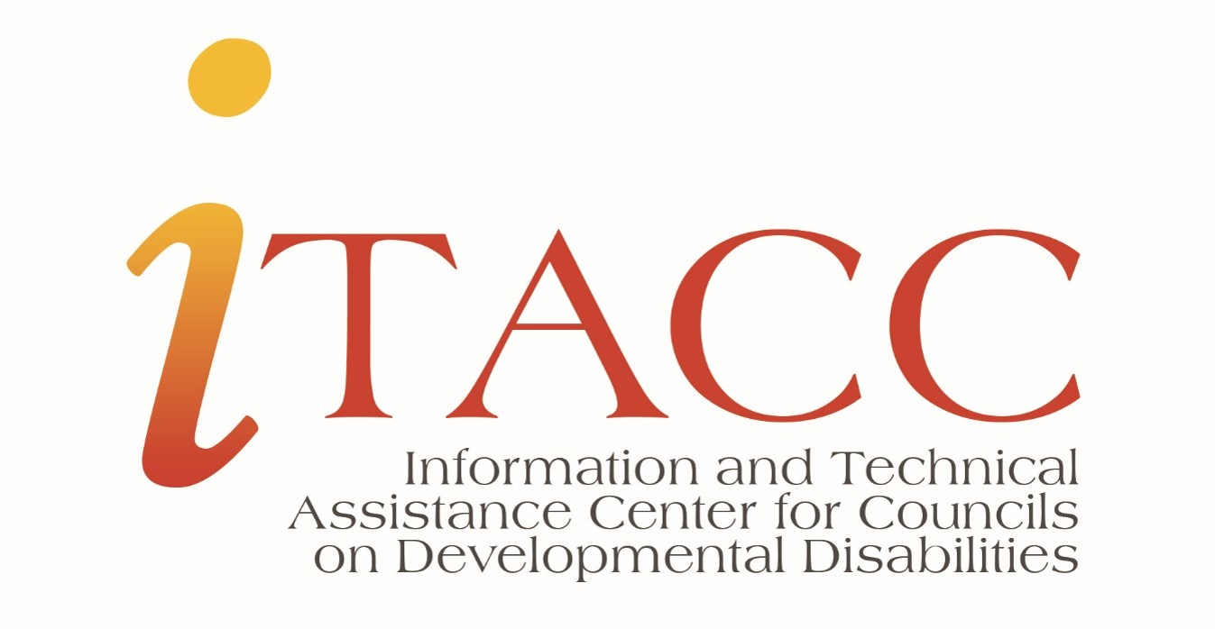

Course Overview: **Welcome! This course provides general information for Council members and staff who serve as an advocate for individuals with Developmental Disorders and their families.**

**This course will focus on the following:**

* The Council’s role as an advocate
* Advocacy activities
* Strategies to educate policymakers
* Coalition development and citizen participation
* Conditions for advocating a position

## Course Objectives:

In this course, you will:

* Examine the Council’s role as an advocate for those with DD
* Define advocacy activities and which are allowable/unallowable for the Council
* Discuss strategies that support educating policymakers
* Describe the conditions necessary to advocate a position or viewpoint

# Lesson 1: The Council as an Advocate

## Developmental Disabilities Assistance and Bill of Rights Act (DD Act)

*“The Council shall serve as an advocate for individuals with developmental disabilities and conduct or support programs, projects, and activities that carry out the purpose of this subtitle.”*[***-DD Act Section 125 (c)(2)***](https://www.google.com/url?q=https://acl.gov/about-acl/authorizing-statutes/developmental-disabilities-assistance-and-bill-rights-act-2000&sa=D&source=docs&ust=1665666961083851&usg=AOvVaw0TFU-zZrBaEi8kSEL-k_6b)

## **Defining Advocacy Activities:**

## What Does the “Final Rule” Say?

In accordance with the DD Act, “advocacy” is defined as:

“Active support of policies and practices that promote systems change efforts and other activities that further advance self-determination and inclusion in all aspects of community living (including housing, education, employment, and other aspects) for individuals with developmental disabilities, and their families.”

# Lesson 2: Educating Policymakers

Councils have a responsibility to educate policymakers and help facilitate changes that lead to positive outcomes for individuals with disabilities and their families.

Specific reference to educating policymakers is found in the following State Plan strategies:

* Coalition Development and Citizen Participation (Section 125 (c) (5) (I))
* Informing Policymakers (Section 125 (c) (5) (J))
* Demonstration of new approaches to services and supports (Section 125 (c)(5)(K))

# Topic 1: Coalition Development and Citizen Participation

**The Council may support and conduct activities to:**

### **EDUCATE**

Educatethe public about the capabilities, preferences, and needs of individuals with developmental disabilities and their families. This includes training in self-advocacy, education of policymakers, and citizen leadership skills.

### **SUPPORT**

Support coalitionsthat support the policy agenda of the Council, including training in self-advocacy, education of policymakers, and citizen leadership skills.

# Topic 2: Informing Policymakers

**The Council may support and conduct activities to:**

Provide information to policymakers by…

Conducting studies and analyses

Gathering information

Developing model policies, approaches, strategies, and procedures Disseminating information, findings, conclusions, and recommendations

Councils must provide the information **directly**to Federal, State, and local policymakers, including Congress, the Federal executive branch, Governors, State legislatures, and State agencies. This increases policymakers’ ability to create positive outcomes for individuals with developmental disabilities and their families by:

* Increasing opportunities
* Enhancing or adapting generic services
* Providing pathways to specialized services

## **Policymakers**

#### **FEDERAL**

* Congress
* Executive Branch

#### **STATE**

* Governers
* State Legislatures
* State Agencies

#### **LOCAL**

* Elected city officials

# Topic 3: Demonstrate New Approaches

The COVID-19 pandemic in the early months of 2020 caused a marked change in the needs and concerns of those with developmental disabilities. For example, limited mobility made it more difficult for people to social distance from moment to moment as circumstances arose. Likewise, those with cognitive impairments and difficulty understanding information did not fully understand guidelines around handwashing, risk levels, virus transmission, etc.

Councils have a responsibility to advocate for changes that improve services for individuals with developmental disabilities. The DD Act Section 125 (c) (5) (K) states that Councils may support and conduct time-limited activities to:

* Demonstrate new approaches to serving individuals with developmental disabilities. Demonstrated approaches should be part of an overall systems change strategy.
* Educate policymakers and the public in ways that contribute to the achievement of the DD Council’s purpose.

# Lesson 3: Advocating for Positions & Viewpoints

**Councils are free to advocate a position or viewpoint…**

**As long as these parameters are followed:**

#### **A full and fair description of the issue to help the policymaker form an independent opinion or conclusion**

#### **Do not present unsupported opinions or facts**

#### **Do not use inflammatory or derogatory terms**

#### **Avoid conclusions based on emotions or feelings rather than objective, factual information**

## **When Advocating for a Position or Viewpoint, Councils Must Be..**

**Fair**

**Civil**

**Detailed**

**Objective**

**Factual**

**Councils can advise legislators and others on the adoption of legislation, as long as these parameters are followed:**

#### **Approach is balanced**

#### **Discussion includes advantages and disadvantages**

#### **There are comparisons to other proposals under consideration**

**Does the Council have to be neutral?**

A Council does **not**have to be neutral about outcomes for people with developmental disabilities.

However, it must demonstrate an unbiased attitude when considering alternatives for meeting the needs of individuals with developmental disabilities.

# Lesson 4: Areas of Caution

# Topic 1: Allowed vs. Not Allowed

DD Councils receive the basic state grant award from HHS (the Department of Health & Human Services). As a recipient of the HHS grant, there are certain limitations on what activities Councils are and are *not*allowed to engage in.

**Allowed**

HHS Grant Recipients *may* engage in the following:

Technical or factual presentations on topics related to the performance of a grant. This may be in response to a documented request made by a member of Congress or other legislative body.

* Nonpartisan analyses, studies, research reports, and examinations
* Broad discussions of social and economic matters, provided upon request by a legislator for technical advice and assistance, as defined by the Internal Revenue Code.
* Any activity specifically authorized by statute to be undertaken with funds from the federal award.

**Not Allowed**

HHS (Department of Health & Human Services) grant recipients **cannot** lobby.

In general, recipients of federal funds *are not allowed*to use federal funding to lobby federal, state, or local officials or their staff to receive additional funding or influence legislation.

Examples:

* Spending federal funds to influence an officer or employee of any agency or Congressional member/staff;
* Using grants funds to influence an election, contribute to a partisan organization, or influence enactment or modification of any pending federal or state legislation; or
* Spending federal funds to influence federal, state, or local officials or legislation.

# Resources

[ITACC Website](https://itacchelp.org/)

[ITACC Technical Assistance Form](https://itacchelp.org/request-technical-assistance/)

[Developmental Disabilities Assistance and Bill of Rights Act 2000](https://acl.gov/about-acl/authorizing-statutes/developmental-disabilities-assistance-and-bill-rights-act-2000)

# Wrap-Up: Leading the Way

* DD Councils provide valuable information to policymakers at all levels of government. DD Councils may determine how to inform policymakers, but they must follow state and federal laws.
* DD Council employees may and should describe the good work that councils do. They should educate and reform.
* Members of Councils should speak on behalf of the Council only when authorized to do so. They should also adhere to policies. Members must represent the Council’s interests and not their own.

# Questions? Comments?

The information in this presentation was provided through funding from the Administration for Community Living, Administration on Disabilities, Office of Intellectual and Developmental Disabilities.

Contract #HHSP23320160068C and updated under contract #75P00121C00067.