*TAALC 101: Listen Up! Series*

**Lesson 5: Strategies for Building Communication**

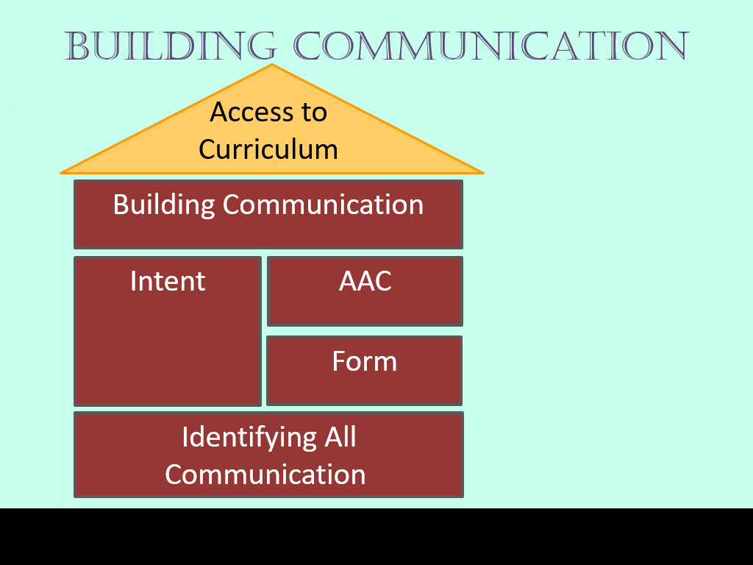

**Learning Objectives:**

* Describe strategies for building communication
* Identify 3-4 strategies you will begin to implement immediately

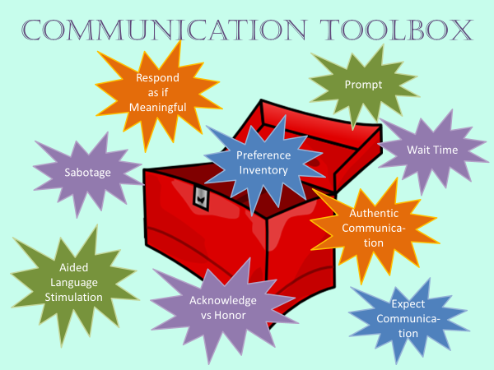

Respond as if meaningful __________________________________________­­­___

Preference Inventory ________________________________________________­

Expect Communication _______________________________________________

Environmental Manipulation (Sabotage)__________________________________

Prompts ___________________________________________________________

Wait Time __________________________________________________________

Authentic Communication _____________________________________________

Acknowledge vs Honor ________________________________________________

Aided Language Modeling _____________________________________________

**Effective Teaching Principles**

* Highly engaging activities
* Frequent opportunities to respond
* High levels of success
* Systematic presentation
* Immediate feedback
* Ongoing analysis of data

***Ideas*:**

**Common Mistakes**

* Failing to recognize idiosyncratic communication
* Waiting for “readiness”
* Testing not teaching
* Compliance vs. communication
* Danger of Yes/No
* Obstructing communication with motor requirements
* Dismissal from Related Service for “Lack of Progress

***Thoughts*** *(Hmm? Have I done that?):*

**References**

Chazin, K. T., Barton, E. E., Ledford, J. R. (2018). Implementation and intervention practices to facilitate communication skills for a child with complex communication needs. *Journal of Early Intervention, 40*, 138-157. doi:https://doi.org/10.1177/1053815118771397

Cowan, R. J. & Allen, K. D. (2007). Using naturalistic procedures to enhance learning in

individuals with autism: A focus on generalized teaching within the school setting.

*Psychology in the Schools, 44(7)*, 701-715. doi: 10.1002/pits.20259

Kaiser, A. P., & Wright, C. A. (2013). Enhanced milieu teaching: Incorporating AAC into

naturalistic teaching with young children and their partners. *Perspectives on Augmentative and Alternative Communication, 22*, 37-50.

Kashinath, S., Woods, J., & Goldstein, H. (2006). Enhancing generalized teaching strategy use in daily routines by parents and children with autism. *Journal of Speech, Language and Hearing Research, 49*(3), 466-485. doi:10.1044/1092-4388(2006/036)

O’Neill, T., Light, J., Pope, L. (2018). Effects of interventions that include aided augmentative and alternative communication input on the communication of individuals with complex communication needs: A meta-analysis. Journal of Speech, Language, and Hearing Research, Vol. 61, 1743-1765.

Sennott, C. S., Light, J.C., & McNaughton, D. (2016) AAC modeling intervention research review. Research and Practice for Persons with Severe Disabilities. 14(12)1-1-115.

Zabala, J., Bowser, G., & Korsten, J. (2004). SETT and ReSETT: Concepts for AT implementation. *Closing The Gap*, Vol. 23, No. 5. Retrieved from <http://joyzabala.com/uploads/Zabala_CTG_SETT_and_ReSETT_.pdf>