*TAALC 101: Listen Up! Series*

**Lesson 4: AAC: Augmentative and Alternative Communication**

**Learning Objectives**

* Understand the three levels of Aided Communication
* Identify the four critical features of Aided Communication
* Learn how to evaluate student’s communication needs via Feature Matching

**Communication Equation:**

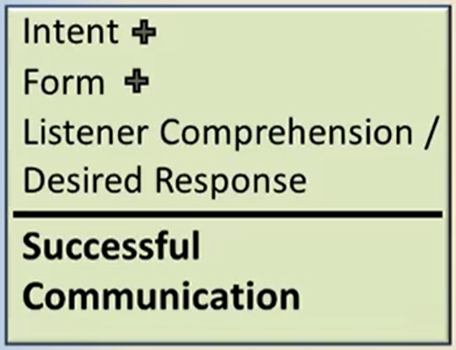

What is the difference between **Augmentative** and **Alternative** Communication?

**Unaided Communication** uses only your body. Give some examples of unaided communication:

**Three Levels of Aided Technology**

* **No Tech**
  + Non-electronic
  + Often handmade
* **Low Tech**
  + Simple Electronics
  + Battery Operated
  + Preprogrammed messages
* **High Tech**
  + Sophisticated Electronics
  + Allows user generated messages

Give examples/descriptions of each level of **Aided Technology:**

1. No Tech –

1. Low Tech –
2. High Tech -

Give examples/descriptions of the four **critical features** of Aided Communication.

1. **Method of Access:**
2. **Form of Representation:**
3. **Display:**
   1. Form of Display:
   2. Organization of Display:
4. **Type of Output:**

***Fill in the Blank***

1. Moveable pictures, books and boards, and simple eye gaze are examples of a **____-tech** communication system.
2. **Low-tech** devices can include both single and _____ - message devices.
3. **_____-tech** devices allow the user to generate their own messages.
4. **Text to _______ systems** are high-tech devices that allow the user to create messages which the device then speaks (aka speech generating devices).

**Feature Matching**

Table 1: Feature Matching

| **Method of Access** | **Representations** | **Type of Display** | **Type of Output** | |
| --- | --- | --- | --- | --- |
| Direct selection | Real objects | Static | Voice | |
| Scanning | Photo | Dynamic | Visual | |
|  | Iconic pictures |  |  |
|  | Line drawing | **Display Organization** |  |
|  | Print | Visual scene display |  |
|  |  | Grid |  |

**Feature matching** looks at a student’s ___________ to determine what kind of system they need.

**References**

Who should be invited to the team when conducting feature matching to select AAC devices?

Beukelman, D. & Mirenda, P. (2013). *Augmentative and alternative communication: Supporting children and adults with complex communication needs (4th ed.).* Baltimore, MD: Brookes.

Calculator, S. N., & Black, T. (2009). Validation of an inventory of best practices in the provision of augmentative and alternative communication services to students with severe disabilities in general education classrooms. *American Journal of Speech-Language Pathology, 18*(4), 329–342.

Ganz, J.B., Morin, K.L., Foster, M.J., Vannest, K.J., Tosun, D.G., Gregori, E.V., & Gerow, S.L.  (2017). High-technology augmentative and alternative communication for individuals with intellectual and developmental disabilities and complex communication needs: A meta-analysis. *Augmentative and Alternative Communication, 33*, 224–238. doi:10.1080/07434618.2017.1373855

Johnston, S., McDonnell, A., Nelson, C., & Magnavito, A. (2003). Teaching functional communication skills using augmentative and alterative communication in inclusive settings. *Journal of Early Intervention, 25*, 263–280.

Johnston, S.S., Reichle, J., Feeley, K., & Jones, E. (2012). *AAC strategies for individuals with moderate and severe disabilities*. Baltimore: Paul Brookes, Publishing Co.

Light, J., McNaughton, D., & Caron, J. (2019). New and emerging AAC technology supports for children with complex communication needs and their communication partners: State of the science and future research directions. *Augmentative and Alternative Communication* DOI: 10.1080/07434618.2018.1557251

TIES Communication Tip #3: *Getting to Know Students Who Use AAC*. Minneapolis, MN: University of Minnesota, The TIES Center. Retrieved from: <https://publications.ici.umn.edu/ties/communicative-competence-tips/getting-to-know-students-who-use-aac>