**Annotate Activity**

Our Annotate activity served as an “unofficial start” to see where the participants were from across the state.

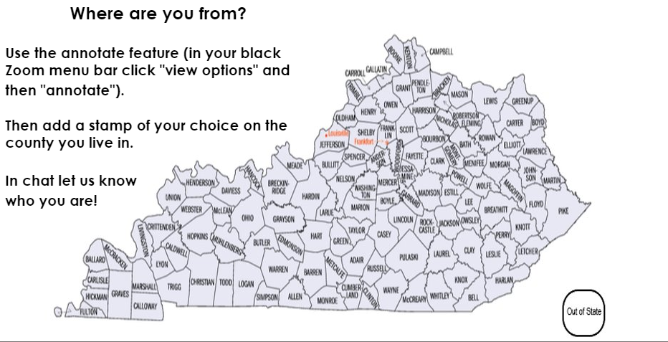

We shared a map on the PowerPoint slide. We instructed participants to the top of their Zoom screen and choose **View Options – Annotate - Stamp** and then mark the map to indicate from which county they were Zooming.

There are several shapes to choose from. You can use annotate with different activities and depending on your content/outcomes, tap into the different features like text, drawing, and highlighting.

You can also create your own document/graphic to share or use a whiteboard for people to annotate. Get creative!

**Have You Ever…?**

***Adapted from an activity in the “Virtual Team Building Games” Zoom session hosted by Michelle Cummings 3/26/2020.***

Ask a series of yes/no questions that require self-reflection and involve participants sharing information about themselves. Sequence the questions intentionally so they start fun/light and progress to deeper reflection/more significant content/tone.

**Questions from Game On!**

1. Binge watched an entire season of a television show in one day.
2. Cut or dyed your own hair.
3. Cancelled face to face training because of a pandemic.
4. Worried about what precautions you would need to take to keep participants healthy/safe in a face to face training.
5. Facilitated a training on racial injustice or anti-bias curriculum.
6. Participated in a public protest.

Have participants perform an action/movement or utilize a video conferencing feature to indicate their yes/no responses and have them pay attention to other participants’ responses. Provide response options so that ALL can participate and allow for anonymous responses with questions of sensitive nature.

**Responses used in Game On!**

1 and 2 – Type Y for Yes, N for No in the chat (and add title of show/details about cut/dye if you wish)

3 and 4 – Yes = stand up or sign for stand up, No = “hand smash” the camera lens

5 and 6 – Vote in the poll (and add details in chat if you wish)

This game adapts easily for use in a variety of ways – as an opener/icebreaker, informal needs assessment, to activate prior knowledge, debrief/knowledge check, energizer/transition, etc.

**Breakout Room Icebreaker - Show and Share Children’s Book**

Email registered participants ahead of the training to ask that they be prepared to show (if they have a copy on hand) and/or just share about a favorite children’s book and what they especially like about the book.

If you are asking a participant to present anything, always let them know ahead of time, so they won’t feel put on-the-spot during the training.

Using a search engine to find icebreakers will produce a very generous cache of results. Some may also be used to energize and support content during your presentation. Keep in mind to match the icebreaker to your groups. For instance, some icebreakers would take too long if you have a lot of people in each breakout room, everyone might not get a turn, or the activity would use up too much of your training content time. Also consider your audience as to whether they may already have some connection. Some icebreakers might make people feel uncomfortable in participation with total strangers.

If you have facilitators, make sure they understand exactly what is to be done. Give clear instructions before sending participants to the breakout rooms. Before going to a breakout session, participants may even want to snap a pic with their phones to capture any instructions given on a power point.

**Additional Resources for Games**

* <https://training-wheels.com/> - free resources, email newsletter
* Training Wheels/Michelle Cummings Youtube channel - <https://www.youtube.com/channel/UC27YUqSukEpFyuIt-JXQrow>
* Michelle Cummings Zoom Webinar on virtual team building games - <https://www.youtube.com/watch?v=rEfpxfmrhvg&feature=youtu.be>
* <https://www.playmeo.com/> - free resources, email newsletter
* Scott Co. Library ‘Creating Board Games’ video - <https://www.youtube.com/watch?v=4k4CDD-UCUs&feature=youtu.be> geared more towards families, but does contain some good information about creating games.
* [www.bustle.com](http://www.bustle.com) free and fun icebreaker ideas
* [www.summitteambuilding.com](http://www.summitteambuilding.com) free ideas to break the ice or energize meetings and trainings.
* Blog.hubspot.com/marketing/ice-breaker-games free icebreaker and energizer ideas that are suitable for team building during meetings or can be used for training.