**How to Annotate in Zoom (when sharing your screen)**  
<https://support.zoom.us/hc/en-us/articles/115005706806-Using-annotation-tools-on-a-shared-screen-or-whiteboard>

1. Log into Zoom online – [www.zoom.us](http://www.zoom.us) 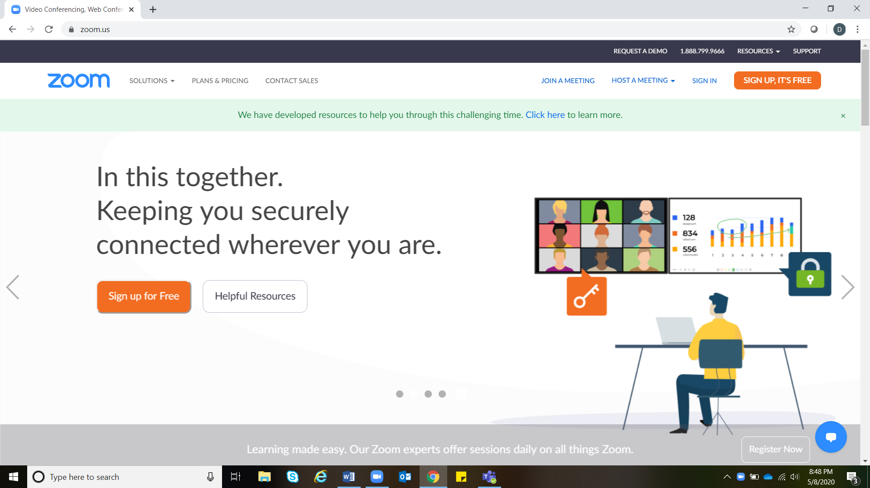
2. Go to settings.

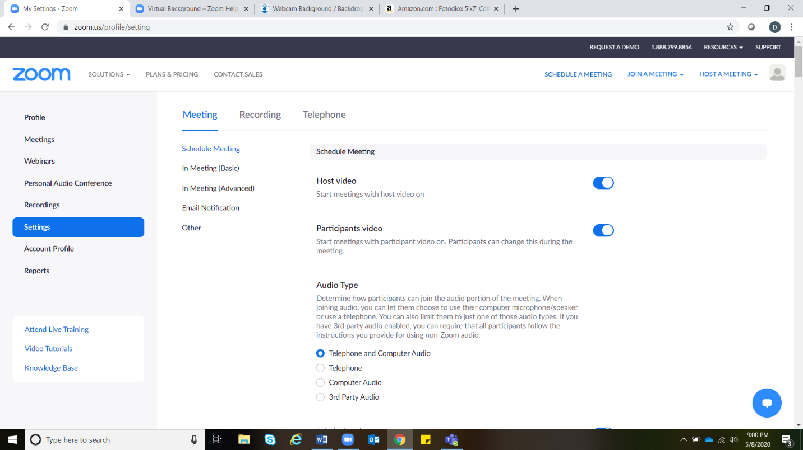Scroll down to “In Meeting (basic)” and “Annotation”. Check to see that annotation is enabled (will be blue). If not enabled, click to enable. Please note you may need to sign in again for setting to update.

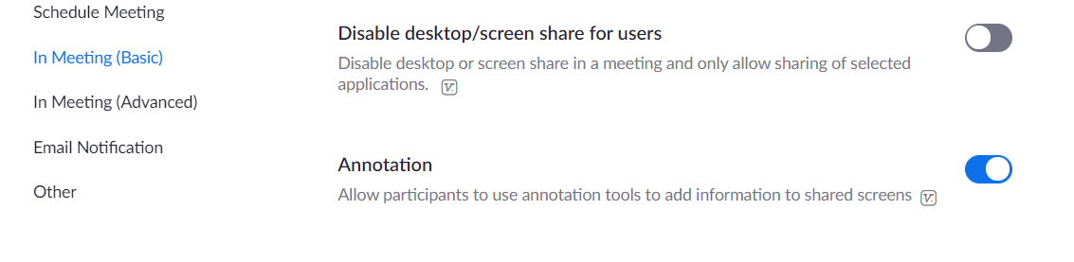

1. In a Zoom meeting share your screen. You can annotate on anything being shared.  
   Once sharing, at the top of the screen in the black bar there is a pencil icon and the word “Annotate” click to access options.

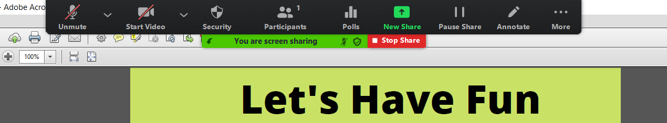

1. In the annotate bar there are a variety of options to choose from. Hovering over some icons may pull up additional options. For example hovering over “stamp” will show various stamp options.

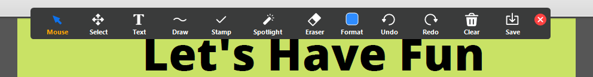

1. Some helpful hints:



* Hovering over “spotlight” will also bring up the “arrow” option.

Spotlight would be used to highlight information on the screen. Participants viewing your screen will be able to see the content with a spotlight on it.

* Eraser and clear both give you the option to delete annotations. Clear give more options and lets you: clear all; clear only your annotations; or clear participant’s annotations. Annotations will follow you as you continue to share your screen. So delete anything you do not want to stay with you throughout your presentation!
* If you are interested in saving the annotations, save takes a screen shot and saves it on your computer.