**How to Add Polls in Zoom**  
<https://support.zoom.us/hc/en-us/articles/213756303-Polling-for-meetings>

1. Log into Zoom online – [www.zoom.us](http://www.zoom.us) 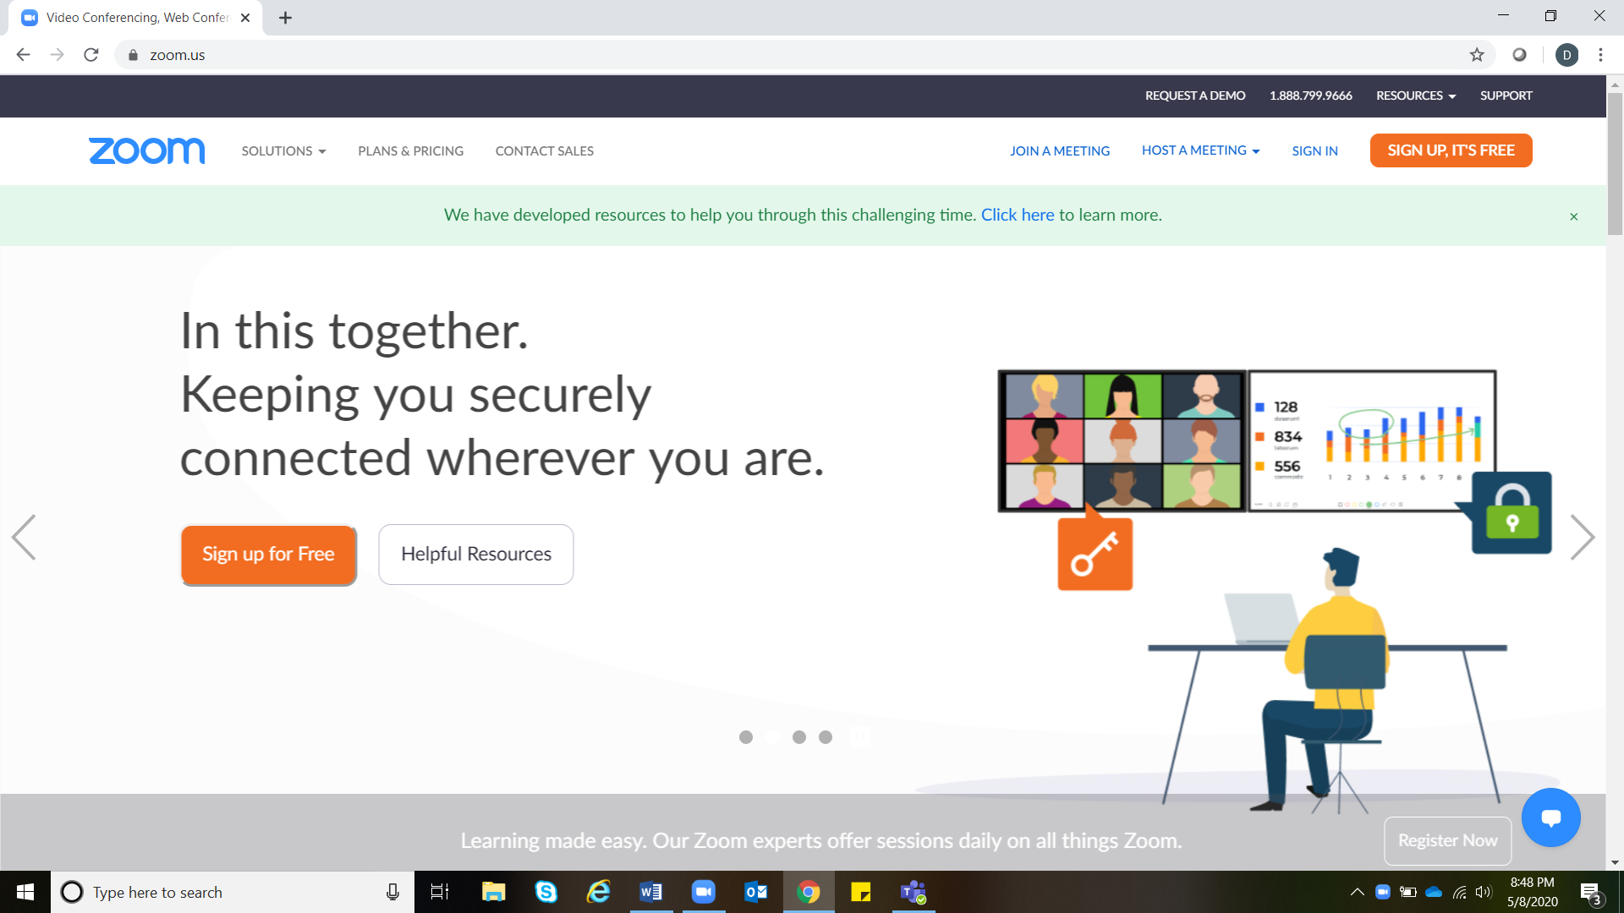
2. Go to settings.

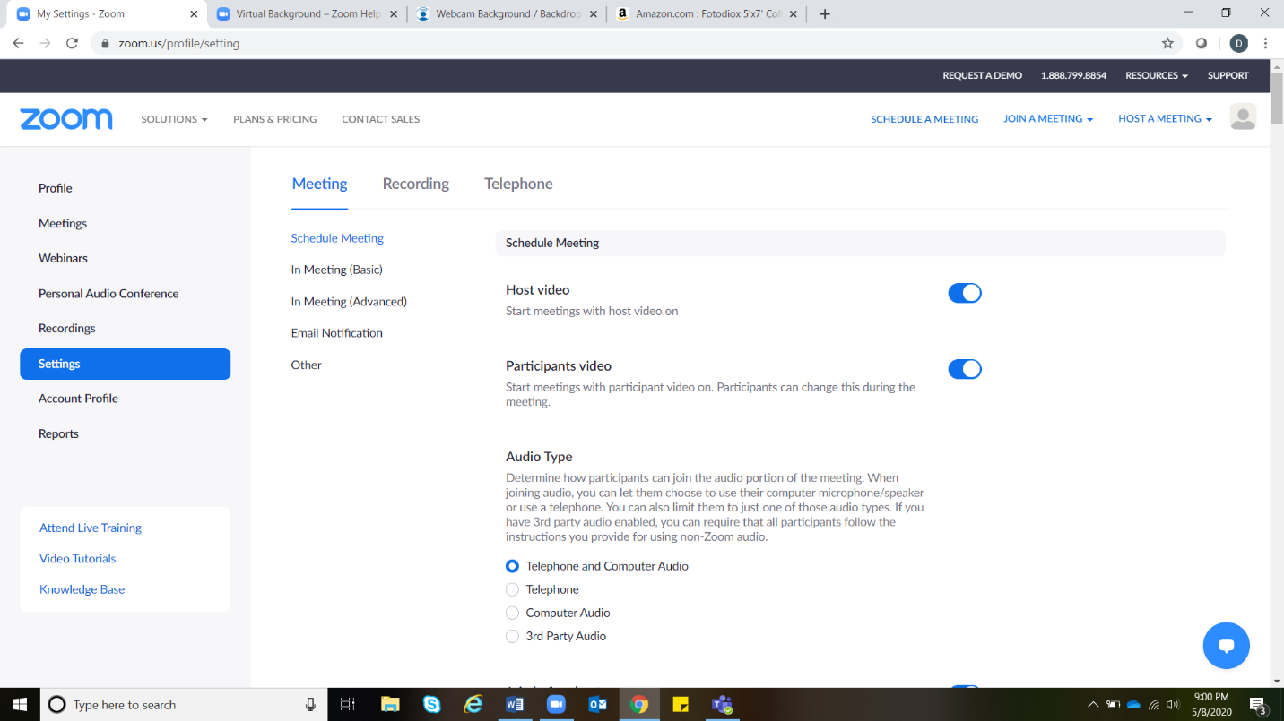Scroll down to “In Meeting (basic)” and “Polling”. Check to see that polling is enabled (will be blue). If not enabled, click to enable. Please note you may need to sign in again for setting to update.

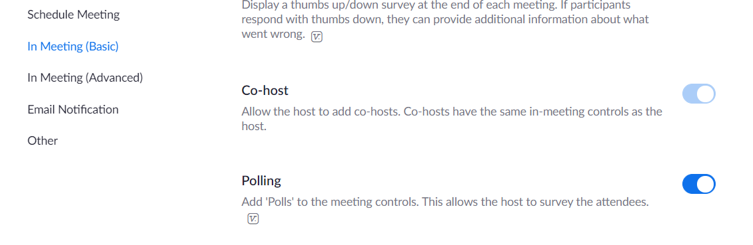

1. To create polls, go to desired Zoom Meeting and click Polls Icon.

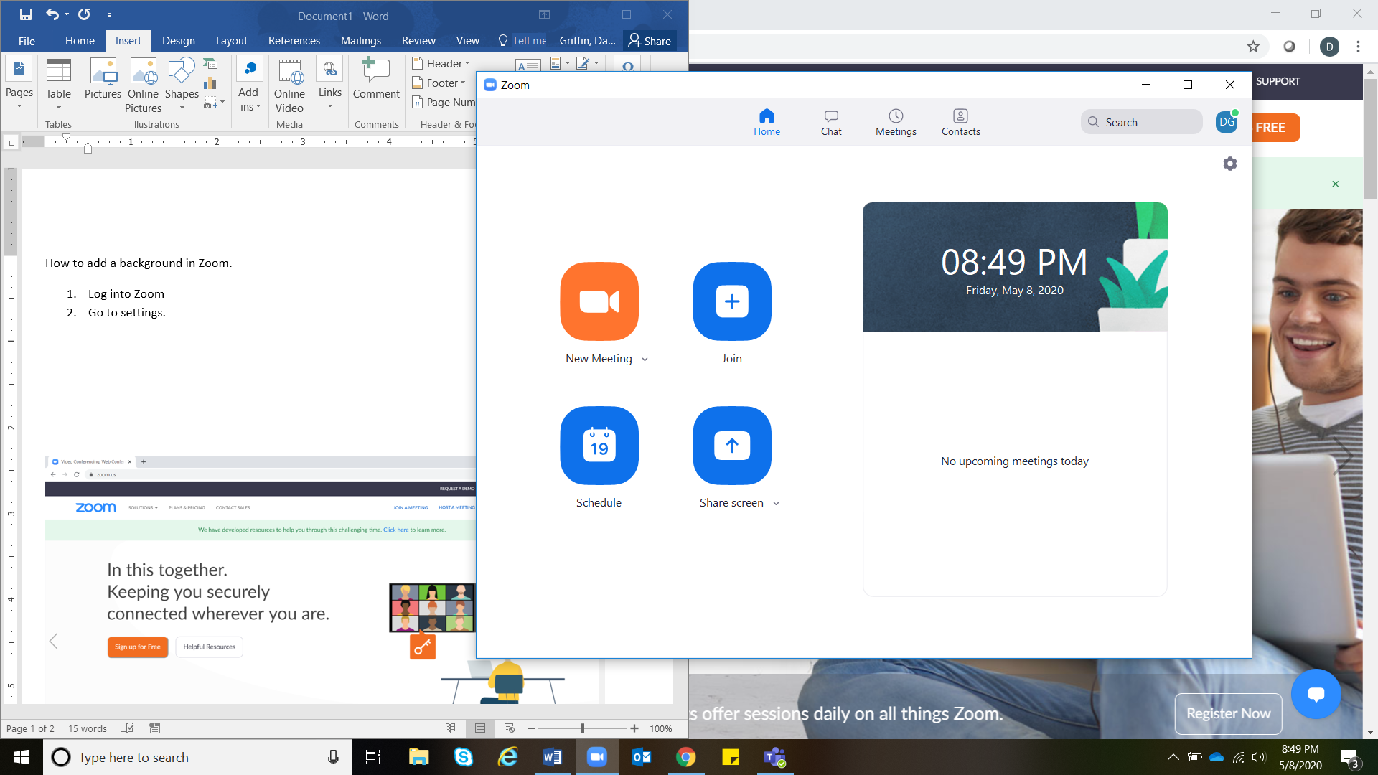

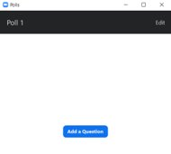

1. In the box, click the box “Add a Question”.
2. 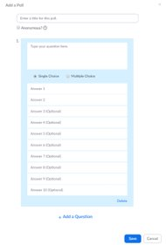In the box write your question, possible answers, and indicate if there will be a single answer or multiple choice. Add as many questions as you want in your session. When you are finished, click “save”.

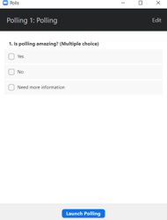

1. Go back to your Zoom Meeting. Click on “Polls” again. The created polls will now appear. To launch the poll click, “Launch Polling”.

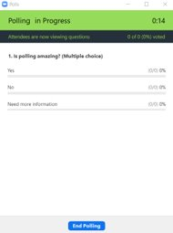

1. As the poll questioned is answered results will pop up. Time that poll has been open is indicated in the top right corner. When you are ready to end the poll click “End Polling”.

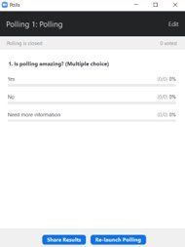

1. Want to share your results with participants? Click “Share Results”. To relaunch polling click “Relaunch Polling”. To end polls click “x” in corner to close out.