**How to Add a Background in Zoom**  
<https://support.zoom.us/hc/en-us/articles/210707503-Virtual-Background>

1. Log into Zoom online – [www.zoom.us](http://www.zoom.us) 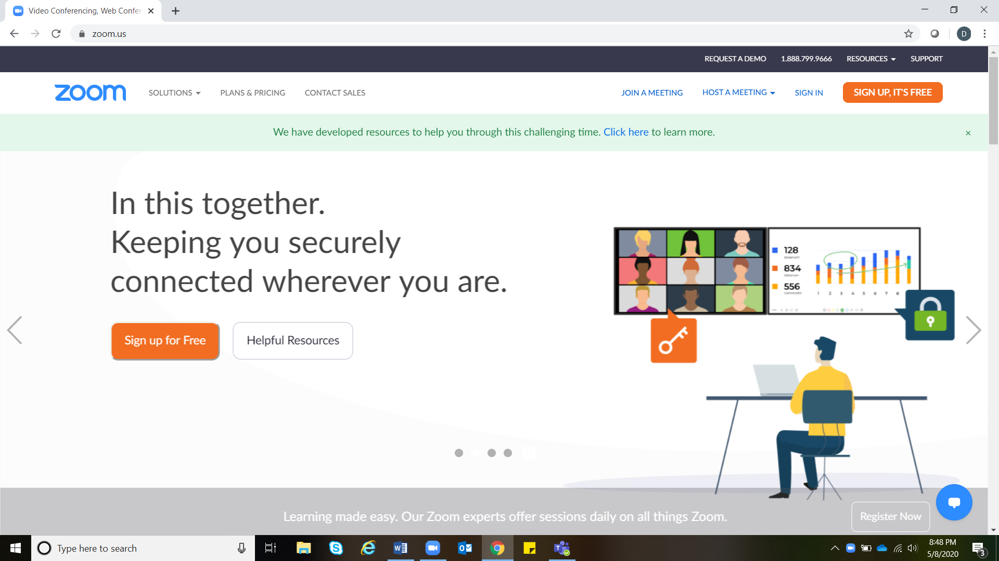
2. Go to settings.

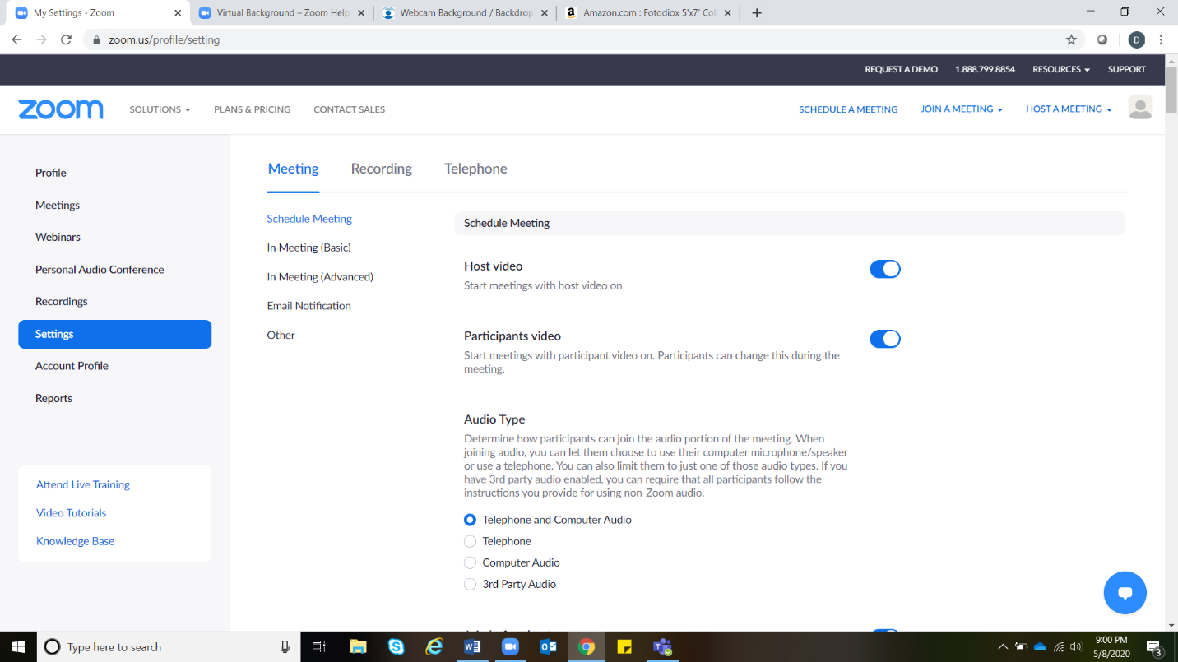Scroll down to “In Meeting (advanced)” and “Virtual Background”. Check to see that the virtual background is enabled (will be blue). If not enabled, click to enable. Please note you may need to sign in again for setting to update.

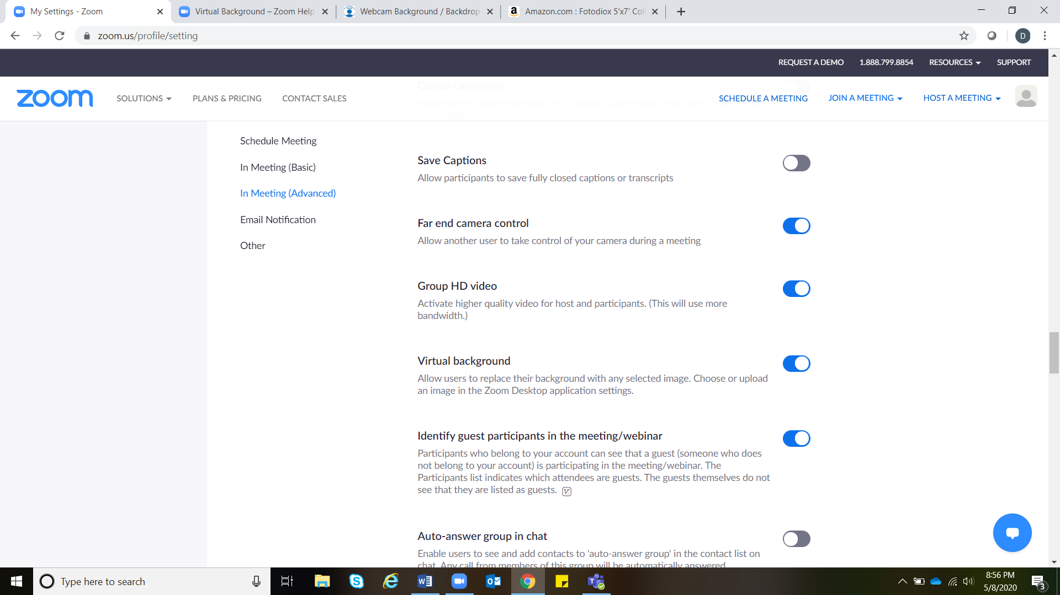

1. To access and change virtual backgrounds sign into the Zoom Desktop App

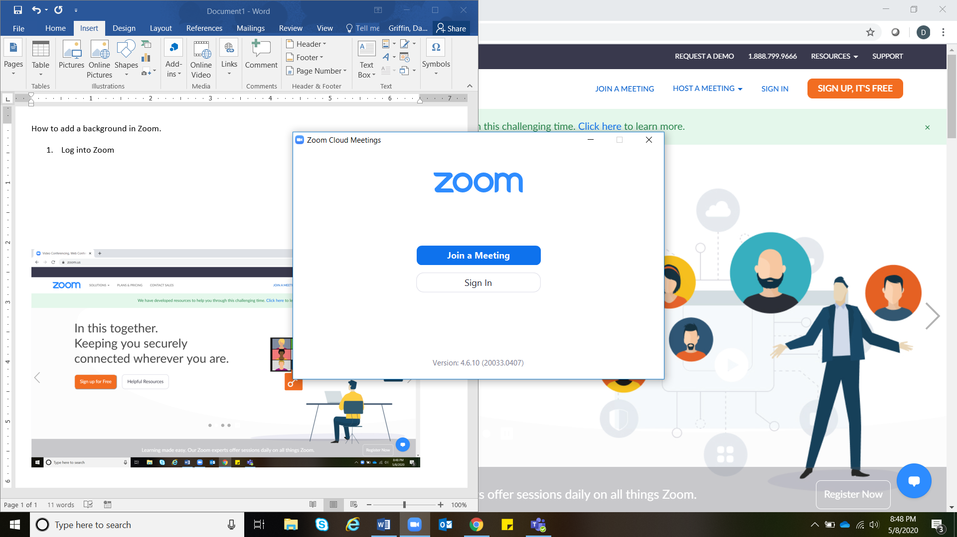

1. Click the gear icon.

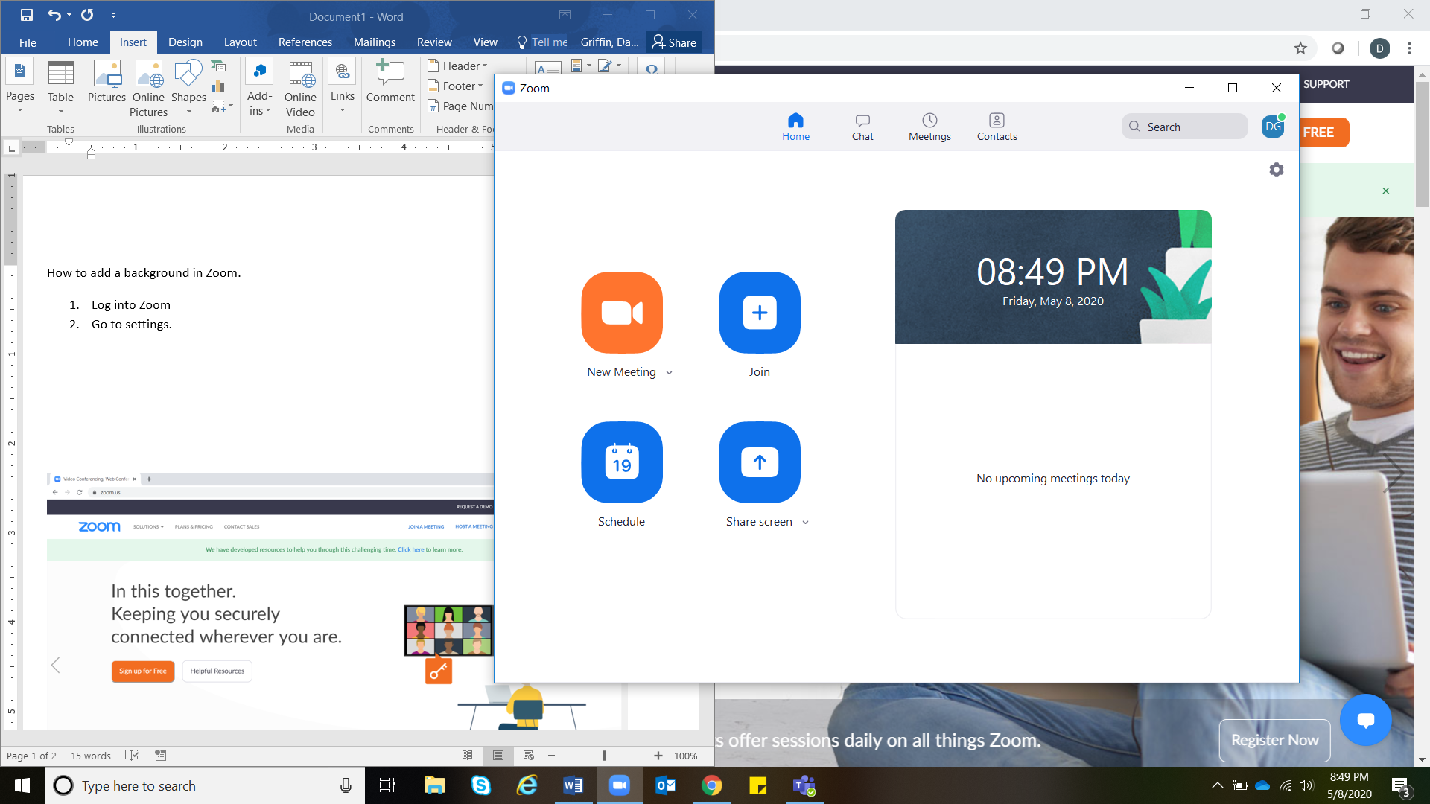

1. On the left hand side, click “virtual background”.

Zoom has several preset backgrounds available. Or there is the option to add a new picture. Choose your desired picture saved on your computer.

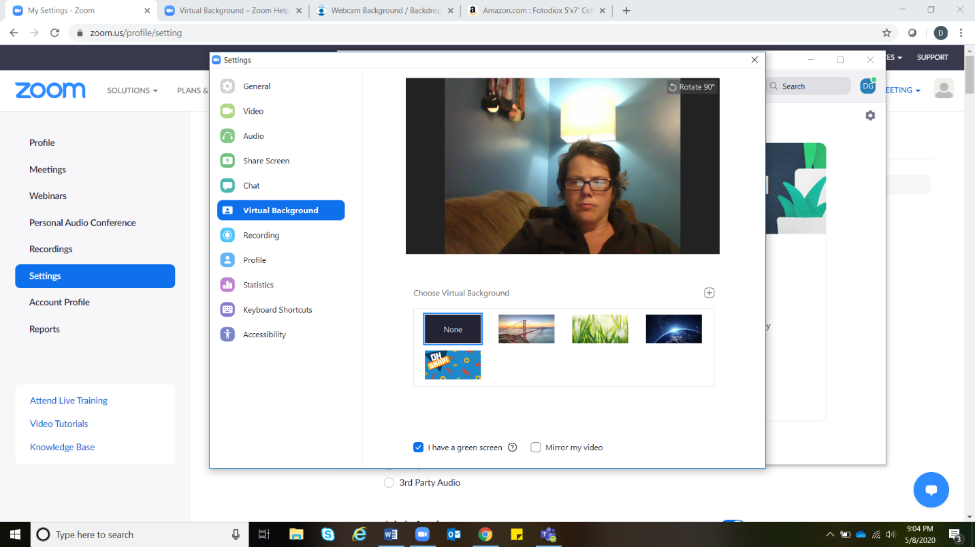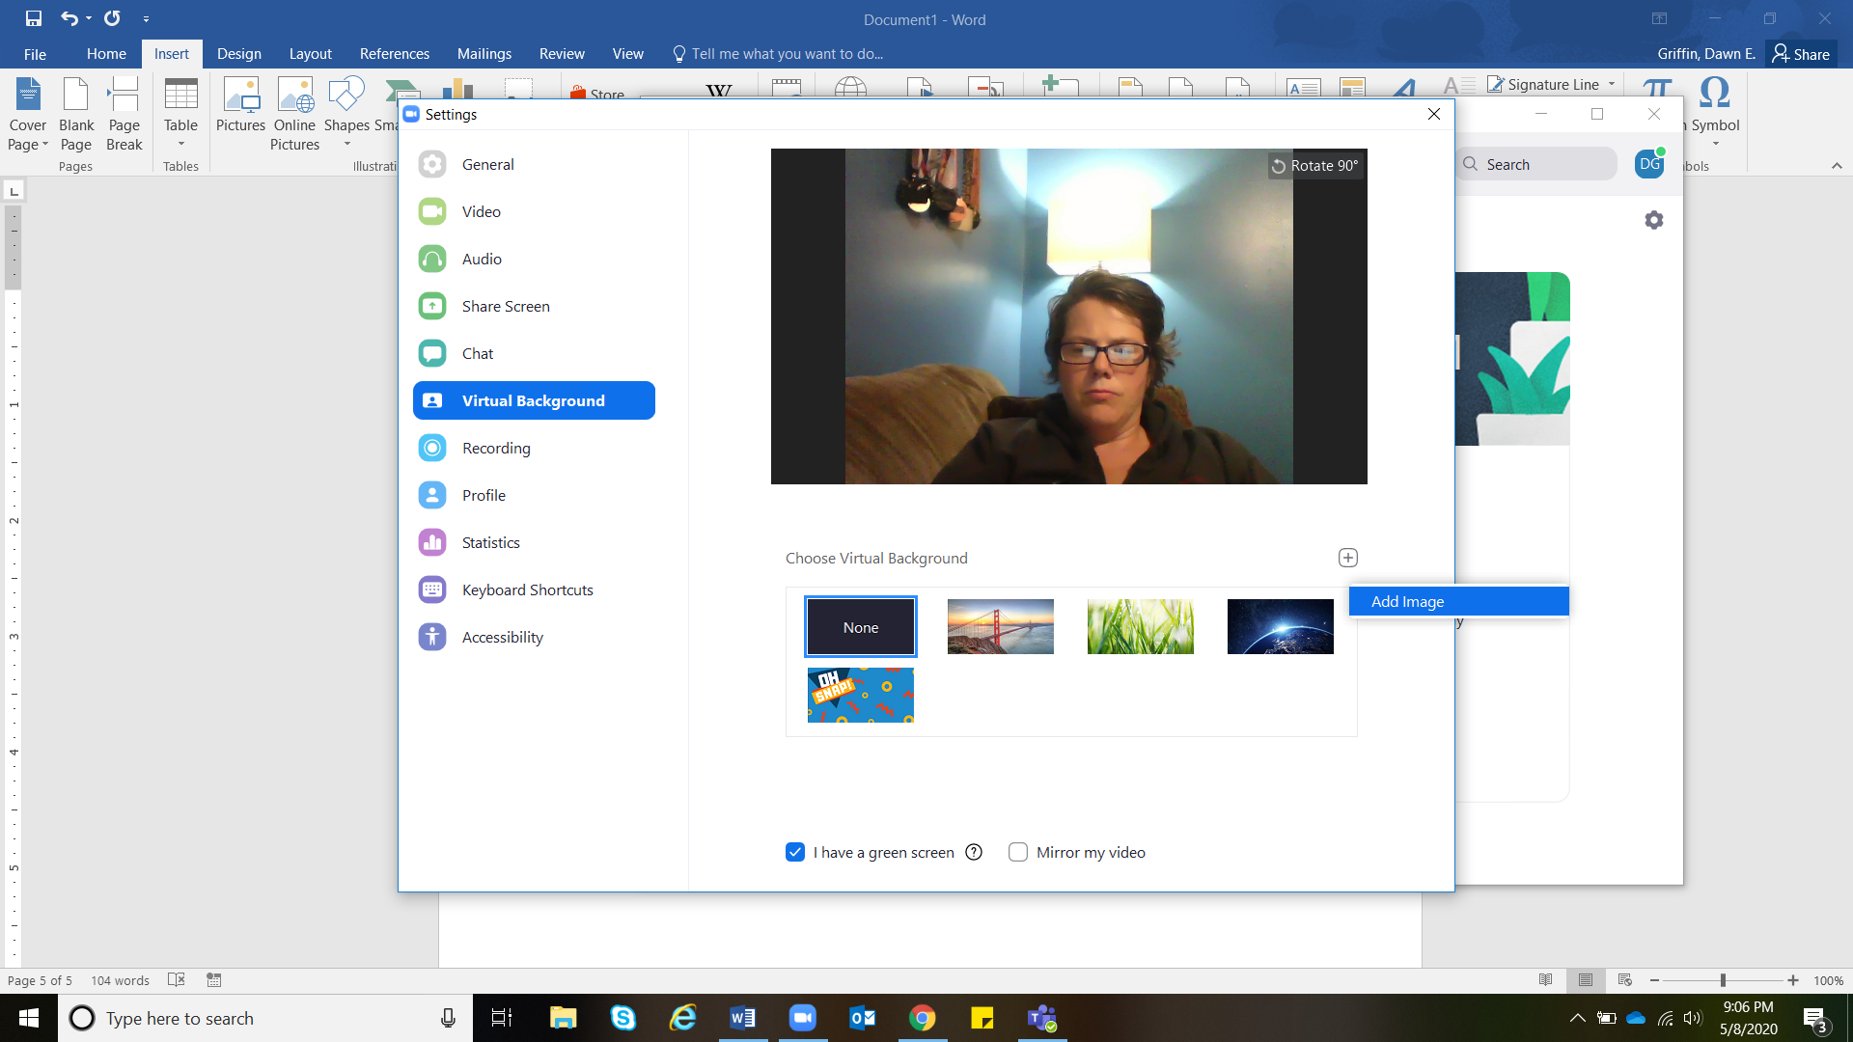

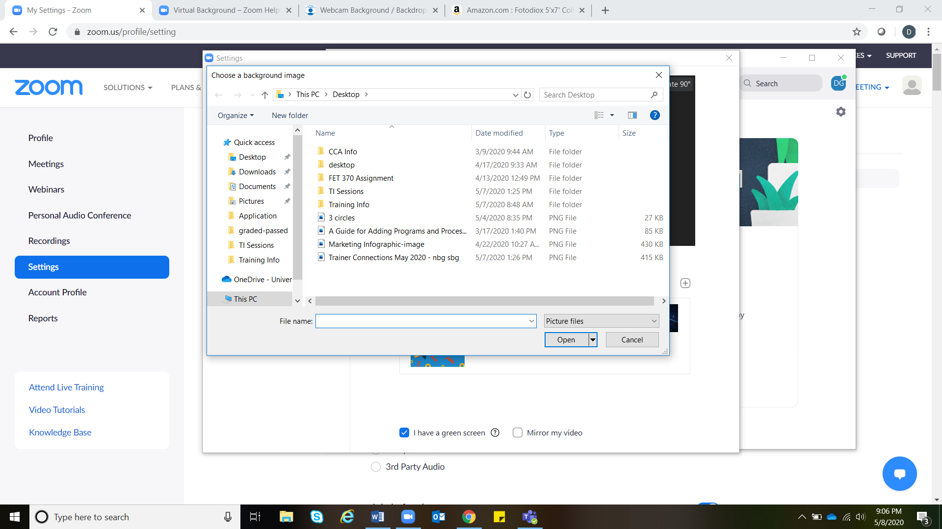

1. To display your virtual background without using a green screen, make sure the “I have a green screen” box is NOT checked.  
   Please note some computers do not meet system requirements to have a background WITHOUT a green screen. If this is the case, then you will have to, either to use a green screen, or not have a virtual background.

 