**Networking**

Organizations to connect with in your community:

**Regional Training Centers**

[Link to list of Regional Training Centers](https://education.ky.gov/curriculum/conpro/prim-pre/Pages/Early-Childhood-Regional-Training-Centers.aspx) with contact information.

**Community Early Childhood Councils**

[Link to description of Community Early Childhood Councils](https://kidsnow.ky.gov/communities/Pages/default.aspx)

[Link to statewide local Community Early Childhood Council locator page](https://kidsnow.ky.gov/communities/cecc/Pages/locations.aspx)

**Division of Child Care Approved Training Agencies**

[Link to list of approved training agencies](https://www.childcareawareky.org/support/professional-development/) (table located near bottom of page)

**Prepared Training Sessions**

[Link to early care and education provider search portal on Benefind](https://benefind.ky.gov/) - download lists of providers with program information

**Present at Professional Conferences**

Lexington Community Action Council Pre-service Conference 2020

Early Childhood Institute

Kentucky Head Start Association Annual Conference

Other opportunities can be found in **Trainer Talk** quarterly newsletter or as shared by your regional **Training Coach**

**Door prize ticket** – participants fill out and turn in for prize drawing at end of conference session (see image next page)

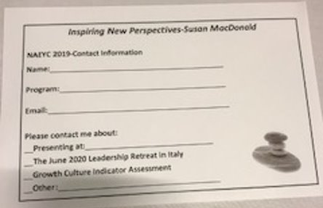

**Social Media/Online Presence**

**Paul Wesselmann** – “The Ripples Guy” – skilled integration: web site, email, Twitter, Facebook, Pinterest, LinkedIn, and YouTube to engage and make meaningful, content-based connections with participants; powerful logo and branding – [Link to The Ripples Guy web page.](https://theripplesguy.com/)

**Facebook 5** – Offer participants a five-minute “break” to check their social media accounts on their phones. Ask them to like/follow/favorite/explore your trainer social media pages while doing this.