**Facebook****:** [**www.facebook.com**](http://www.facebook.com) **- free**

* Facebook Live
* Units
* Events
* Watch parties

**Zoom****:** [**https://zoom.us/**](https://zoom.us/) **- free meetings (up to 100 ppl), 40 min. max**

* Can add to calendar
* Chat options
* Screen sharing options
* Call in options
  + - * Instant meetings
* Meeting rooms

**Skype:** [**https://www.skype.com/en/**](https://www.skype.com/en/) **- free video calls (up to 50 ppl)**



* Can add to calendar
* Options to create from outlook
* Can share screens
* Call in options
* Can IM or direct call

[**SeeSaw: Available iOS App & Web browser**](http://bit.ly/kysteseesaw20)**:** [**https://web.seesaw.me/**](https://web.seesaw.me/)

* Cross-platform & Free
* Not time-sensitive -convenient for families with limited devices/time
* Thousands of lessons available for all grade-levels
* Multiple options for students to respond
* Controlled privacy settings



* Unique family login to view their child’s work
* Teacher can enable commenting from parents

[**Flipgrid: Available iOS App & Web browser**](https://blog.flipgrid.com/amplify/#flipgridresources) [**https://info.flipgrid.com/**](https://info.flipgrid.com/)

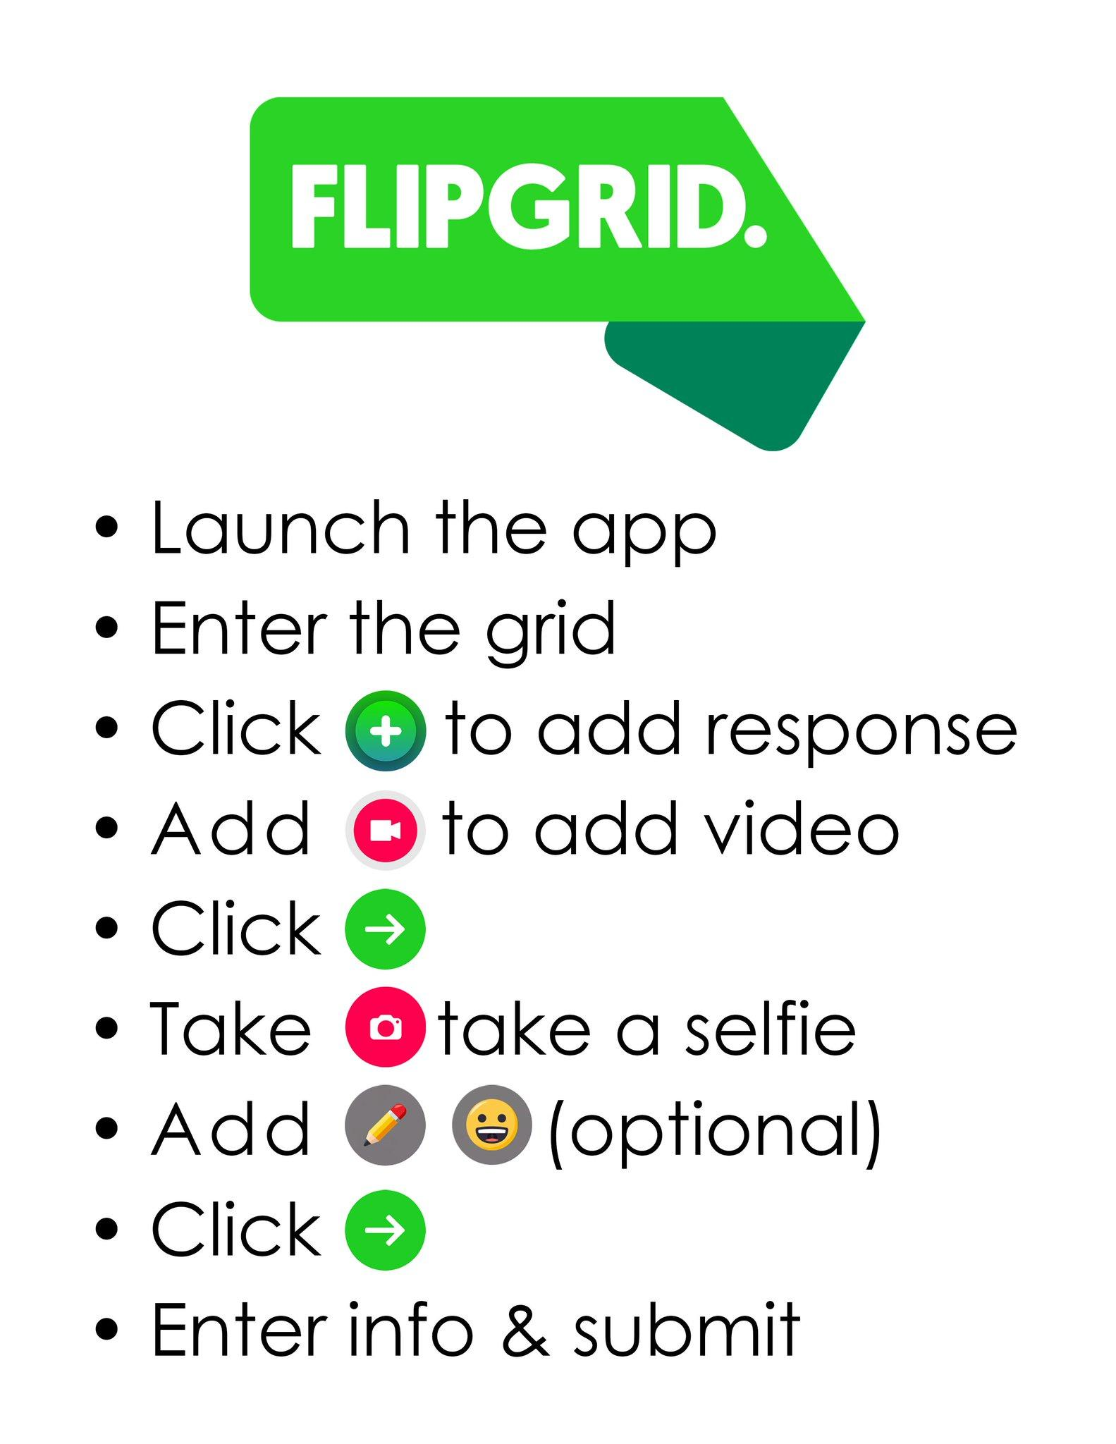

* Cross-platform & Free
* Not time-sensitive -convenient for families with limited devices/time
* Controlled privacy settings
* Disco Library contains lesson ideas