Table of Contents p2
Index p42

www.kentuckypartnership.org
Patricia Singleton
Tech for Trainers Online Training
Session Handout and Additional Materials

Training into Practice Project | Kentucky Partnership for Early Childhood Services | Human Development Institute
University of Kentucky © 2014

More Power in Your Point:
Using Microsoft PowerPoint to Enhance Presentations
Table of Contents
Shortcut 4
Clip Art 7
What is Clip Art? 7
Why use clip art? 7
Pro’s and Con’s of clip art 7
Editing Clip Art 9
Recoloring Clip Art 11
Custom Animation 11
What is it? 12
Uses for Custom Animation 12
How to add Custom Animation 12
Video Clips 13
Types of video clips 13
Issues when using video clips 13
How to add a video clip 14
PowerPoint Theme 15
What is a PowerPoint theme 15
Finding PowerPoint themes 15
Slide Master 17
Creating Screenshots 19
What are screenshots? 19
To ‘capture’ a screenshot 19
Custom Slide Show 20
What is a custom slide show? 20
How to create a custom slide show? 20
Opening a Custom Slide Show 21
PowerPoint Printing Options 22
Print Range 22
Print What 22
Importing External PowerPoint Slides 23
What is importing external PowerPoint slides? 23
How will I reuse PowerPoint slides? 23
PowerPoint Slide Library 23
Creating Linked Slides 25
What are linked slides? 26
How can I use linked slides? 26
How to create a link within a slide? 26
Other Links 26
Integrating Microsoft Products 27
To insert an Excel Workbook object 27
To create a chart or table within PowerPoint 28
Practice pasting Excel objects 28
Paste Options: 29
PowerPoint Games 30
PowerPoint Viewer 30
Other Presentation Software 30
Save Options 31
Save to CD 31
Save as PDF 31
Downloading Adobe PDF to your computer 31
Citations in PowerPoint 31
Where can I find information about citations 31
Copyright Resources 31
The Art of Presenting a good Presentation 32
What a Good Presentation Looks Like 32
Choosing the Right Colors 32
Index 34


Shortcut

What is a Shortcut?
Shortcuts are combinations of keystrokes to quickly accomplish computer functions such as editing, inserting, opening programs and switching documents. These shortcuts can be a real time saver – if you know how to use them.
Some shortcuts are universal; they can be used in every computer program. Examples are Ctrl-C (copy) Ctrl-V (paste) Ctrl-X (cut) and Ctrl-P (print). Other shortcuts can be used in every Microsoft Office® Program. Examples are Ctrl-S (save) Ctrl-A (select all).
The following list of shortcuts can be used in Microsoft Office PowerPoint. Keep this list handy, and highlight the shortcuts you may use often.
Please note: not all shortcuts will work using Microsoft Windows Vista or Macintosh computers.
PowerPoint Shortcut Keys
Action | Key(s) | Notes
Bold | Ctrl-B
Close | Ctrl-W  Ctrl-F4
Copy | Ctrl-C
Cut | Ctrl-X
Find | Ctrl-F
Italics | Ctrl-I
Gridlines, show/ hide | Shift-F9
Guide, show/ hide | Alt-F9
Guide/Grid options | Ctrl-G
Menu bar | F10
Move to the end of the entry | End
New (slide) | Ctrl-N
Next window | Ctrl-F6
Open | Ctrl-O
Outline: Collapse | Alt-Shift –
Outline: Demote paragraph | Alt-Shift-Right
Outline: Expand | Alt-Shift +
Outline: Move paragraph down | Alt-Shift-Dn
Outline: Move paragraph up | Alt-Shift-Up
Outline: Promote paragraph | Alt-Shift-Left
Outline: Show All Headings | Alt-Shift-A
Outline: Show heading level 1 | Alt-Shift-1
Paste | Ctrl-V
Print | Ctrl-P
Repeat Find | Shift-F4
Repeat/Redo | Ctrl-Y
Replace | Ctrl-H
Save | Ctrl-S
Select all | Ctrl-A
Slide Show: Begin the slide show | F5
Slide Show: Begin the slide show at current slide | Shift-F5
Slide Show: Black screen show/hide | B  . (Period)
Slide Show: End | Esc
Slide Show: Erase annotations | E
Slide Show: Display shortcut keys | F1
Slide Show: Go back to first slide | 1 – Enter  Hold both mouse keys for 2-sec
Slide Show: Go to next hidden slide | H
Slide Show: Hide pointer and button always | Ctrl-L
Slide Show: Hide pointer and button temporarily | Ctrl-H
Slide Show: Mouse pointer to arrow | Ctrl-A
Slide Show: Mouse pointer to pen | Ctrl-P
Slide Show: Next slide | N  Enter  Page Down  Right Arrow  Down Arrow  Space Bar  Mouse Click
Slide Show: Previous slide | P  Page Up  Left Arrow  Up Arrow  Backspace
Slide Show: Set new timings while rehearsing | T
Slide Show: Stop/restart automatic slide show | S  +
Slide Show: Use mouse-click to advance (rehearsing) | M
Slide Show: Use original timings (rehearsing) | O
Slide Show: White screen show/hide | W  , (comma)
Spelling and Grammar check | F7
Switch to the next presentation window | Ctrl-F6
Switch to the next tab in a dialog box | Ctrl-Tab  Ctrl-Page Down
Switch to the previous presentation window | Ctrl-Shift-F6
Switch to the previous tab in a dialog box | Ctrl-Shift-Tab  Ctrl-Page Up
Thesaurus | Shift-F7
Turn character formatting on or off | Num /
Underline | Ctrl-U
Undo | Ctrl-Z

Clip Art

What is Clip Art?

Why use clip art?
Clip art can be used to emphasize a
    - Cliché
    - Icon
    - Metaphor
    - Sign
    - Symbol
    - Visual Pun

Pro’s and Con’s of clip art
As previously stated, clip art can be used to enhance, engage, but it can also distract. Overuse of clip art, graphics and animation in a presentation can often distract a participant.

Guidelines for using clip art.
Emphasize ideas, not every word.
Look for new clip art. Don’t continue to use the same graphics. Microsoft Office online continues to update their clip art library.

What additional guidelines will you follow when using clip art? (write in)

Copyright Notice
WARNING: Copyright Laws prohibits you from using online pictures, clip art and other material without permission! www.creativecommons.org
Microsoft gives permission to its licensed users to use clip art and other electronic media it provides in its Office® products and online. However, other sites may not give the same carte blanche permission. Check with a websites legal or privacy statement before downloading or copying.
You can also give credit for a clip art, photograph or other media you have downloaded. Similar to the tagline added to photographs published in the newspaper, make sure to cite the source of the clip art, photograph or other media.
An example of the Microsoft Office Media Element usage statement (Word Help, Microsoft Office® 2007)
Although these examples do not represent an exhaustive list, you are not permitted to do any of the following with the photos, clip art, font images etc. (“Media Elements”) in the Software Product:
- You may not sell, license or distribute copies of the Media Elements on a stand-alone basis or as part of any collection, product or service where the primary value of the product or service are the Media Elements.
- You may not use or distribute any of the Media Elements that include representations of identifiable individuals, governments, logos, initials, emblems, trademarks, or entities for any commercial purposes or to express or imply any endorsement or association with any product, service, entity, or activity.
- You may not create obscene or scandalous works, as defined by federal law at the time the work is created, using the Media Elements.
- You must indemnify, hold harmless, and defend Microsoft from and against any claims or lawsuits, including attorneys’ fees, that arise from or result from the use or distribution of Media Elements as modified by you.
- You must include a valid copyright notice on your products and services that include copies of the Media Elements.
- You may not permit third parties to distribute copies of the Media Elements except as part of your product or service.

Editing Clip Art
You are able to edit most Microsoft Office® Clip Art, allowing you to customize the colors and elements within the clip art. This will only work on Microsoft Office® Clip Art. Not all clip art can be edited, and some require more advanced programs such as Adobe Photo Shop to edit.

Why Edit Clip Art?
Finding the perfect piece of clip art can be hard. Editing clip art allows you to make the clip art suit your need. You are able to edit clip art to:
- Change colors
- Edit/add text
- Add/delete shapes
- What else can you do? (write-in below)

How do you Edit Clip Art?

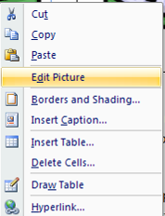
The following steps outline how to edit clip art.
3)
4))
- Insert Clip Art to your document by using the instructions below.
- Insert the clip art by clicking once on the clip art, or select the drop-down menu and choose Insert…
- Click once on the Clip Art to make it active. A box with 8-points will appear around the clip art.
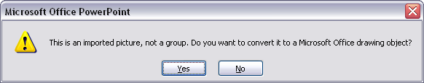
- Right click, and select Edit Picture.
5)
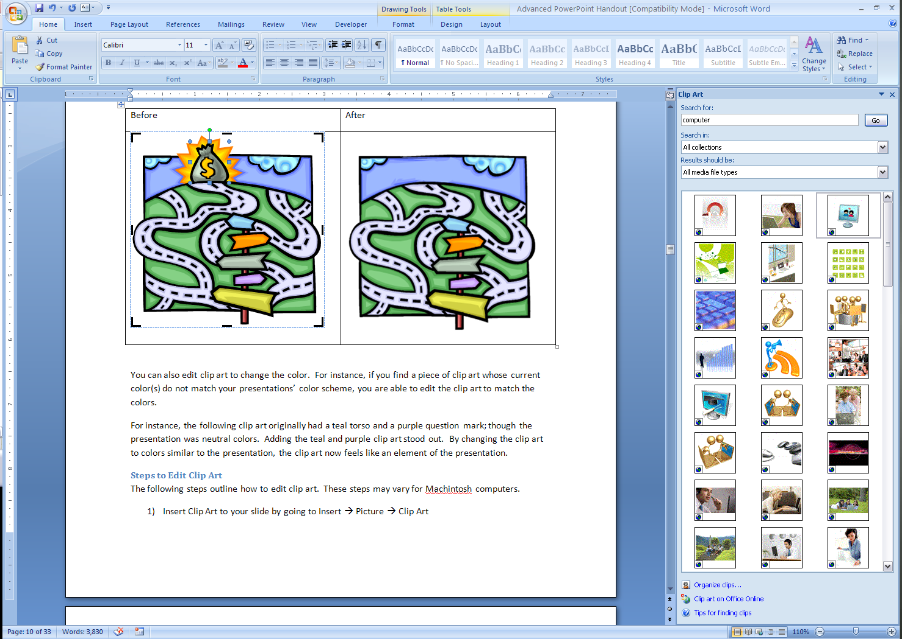
If the Edit Picture option is grayed-out, that clip art is not able to be edited.
6)
- A warning will appear, making sure you want to convert to a drawing object. Click Yes.
- Select the elements you wish to edit. In the example to the right, the money bag has been selected.
- Next steps…
Microsoft Office 2007+ | Go to the Drawing Tools: Picture or Picture Format ribbon to view the various edit functions.  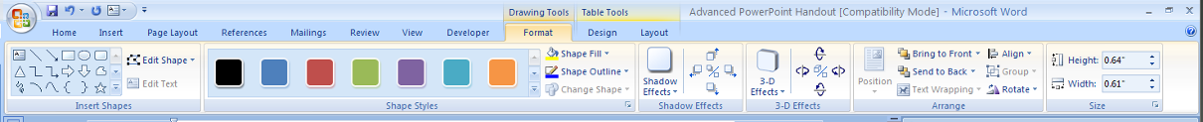

Additional videos on editing clip art https://www.youtube.com/results?search_query=editing+clip+art

Recoloring Clip Art
Clip art can be a wonderful addition to a presentation, but when colorful clip art is printed using a black and white printer, the integrity of the image can be lost.
Light colors look faded when printed and similar colors run together, but color copies are often cost-prohibitive.
One option is to recolor the clip art to grayscale, which uses various shades of grey and black to color the clip art.

Recoloring Options
Automatic (original) | Grayscale | Black and White | Washout
 |  |  | 

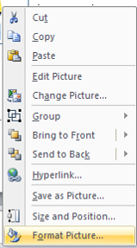
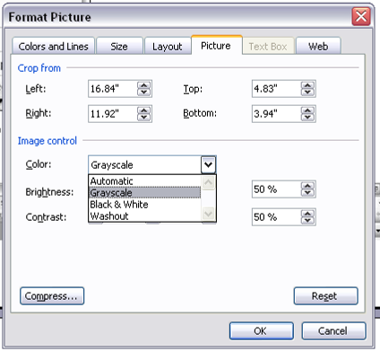
To recolor, right-click on the clip art and choose Format Picture. You may also use the Picture Tools menu or ribbon.

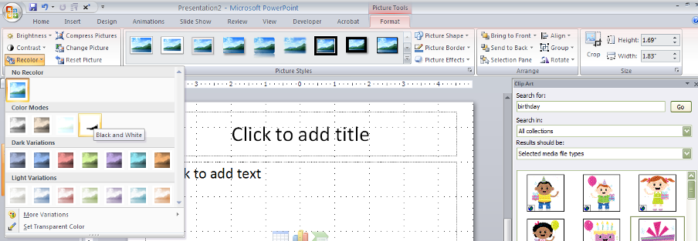

Custom Animation

What is it?
Fill in the 4 types of custom animation below:

Uses for Custom Animation
Media is not a substitute for meaningful instruction – avoid “bells and whistles”
First Principals of Instruction Ecelearn.com
- Engage audience
- Informal assessment
- Play games
Additional Uses (write-in)

How to add Custom Animation

Microsoft Office 2007+ | - Highlight the element you want to animate. If you want to animate all text, do not select any text.  - Go to the Animations ribbon.  - In the Animations section, choose “Custom Animations”  - The Custom Animations window will appear to the right.  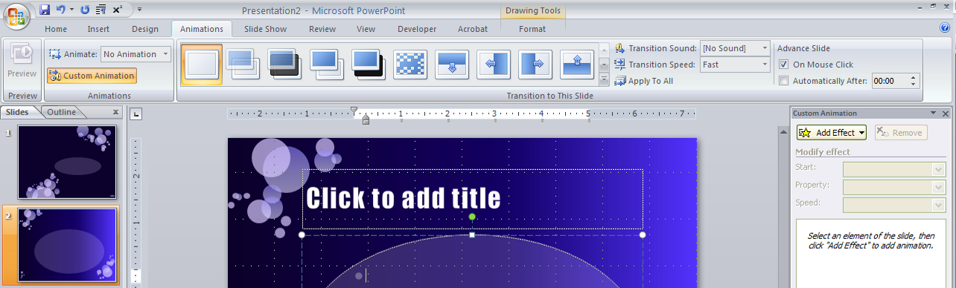

Once the Custom Animations window is on the right, you may begin adding animation to your slide. Select your text, and then in the Custom Animation window, select “Add Effect.”
Video Clips

Types of video clips
- Saved on your computer
- Online

Issues when using video clips
- Format
Some videos are formatted to only play in certain types of video players. If you plan to use a computer other than your own, verify that the file will be able to be played before the presentation. There are different codecs you can download to your computer to allow the play of different file types.
- Size
Large videos may take some time to load and play.
- Sound
Don’t make assumptions about speakers and sound. If you plan to play a video with sound, or a sound clip, verify before the presentation that adequate speakers will be available. Laptop speakers are rarely able to project sound loud enough for even a small training room.
- Quality
Videos viewed on your computer screen will be vastly different than those projected on a screen. Additionally, not all LCD projectors will project at the same quality. View a few moments of a video before a presentation to ensure the quality will enhance, not distract the audience
- File location
Inserting a video or sound clip in a PowerPoint presentation actually only adds a link from the original file to the PowerPoint. If you save a presentation to a disc, you will need to save a copy of the video or sound file as well. Links break easily!

Additional Notes:

How to add a video clip
If the clip is saved to your computer:
Microsoft Office 2007+ | - Go to the Insert ribbon  - In the Media Clips section, click on Movie or Video  - Choose Movie from File  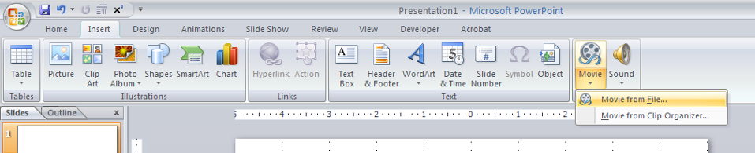

Inserting a video in PowerPoint: https://www.youtube.com/results?search_query=insert+a+video+in+PowerPoint
Patti’s Tip: if you are not comfortable editing a master slide (or don’t know what that means) you might not be ready to insert a video in a PowerPoint.

Video clip options
After you have inserted a video clip, the following options will appear:
Play the video Automatically or
When Clicked

Guidelines for using Video clips
- Don’t show more than 20 minutes of video at a time. The attention span of a typical adult is about 20 minutes
PowerPoint Theme

What is a PowerPoint theme
A PowerPoint theme or template specifies the:
- background
- title font, size, color, position
- body font, size, color, position
- chart color, font, size
- header, footer
for each slide type. The theme is determined by the slide master. Microsoft Office PowerPoint has themes already installed in your version of PowerPoint.

Finding PowerPoint themes
- Microsoft PowerPoint (already installed)
Microsoft Office 2007+ | - Go to the Design ribbon.  - Look for the Themes section.  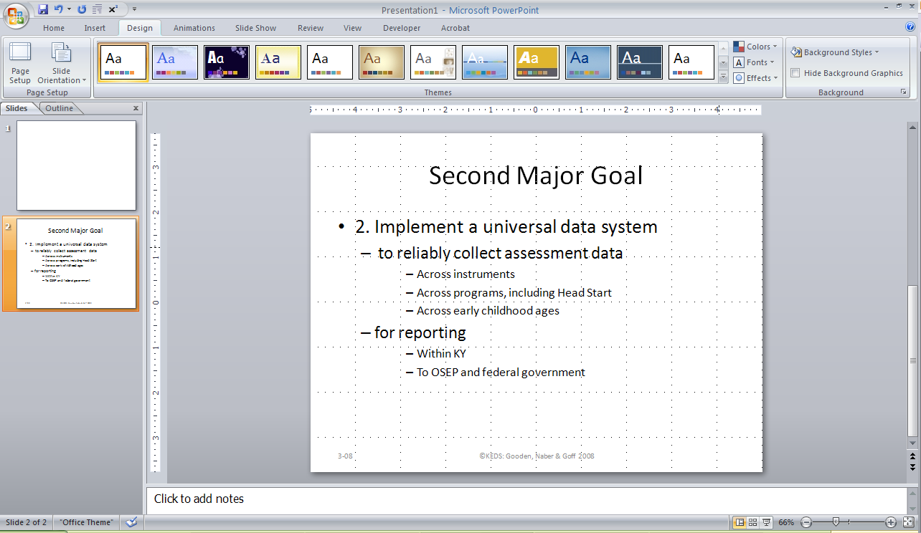

www.microsoftoffice.com
  - Search for PowerPoint templates.
  - Select the template you wish to download.
  - The template will now be included with the other themes. Use the instructions above to apply to your presentation.
Other sources of themes:
- Internet
  - www.google.com search for PowerPoint theme or template
  - Some websites allow you to build your own custom PowerPoint theme
- Hire someone to build a theme for your company to use!
- Trainer supply companies

Slide Master
The slide master (or master slide) is the blueprint that determines the design, font, font size of the presentation. You are able to edit the slide master to customize your presentation.

To access the Slide Master
Microsoft Office 2007+ | View ribbon à Presentation Views à Slide Master  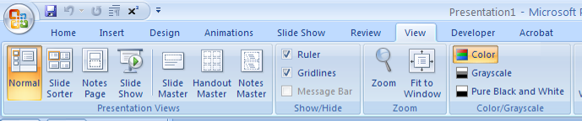

TIP – I recommend creating a new PowerPoint presentation; make changes to the Master Slide, then either import the existing PowerPoint presentation or apply a saved template. Information on merging/reusing slides is included in the Importing External PP Slides section of this document.

Viewing the Slide Master
Microsoft Office 2007+ | 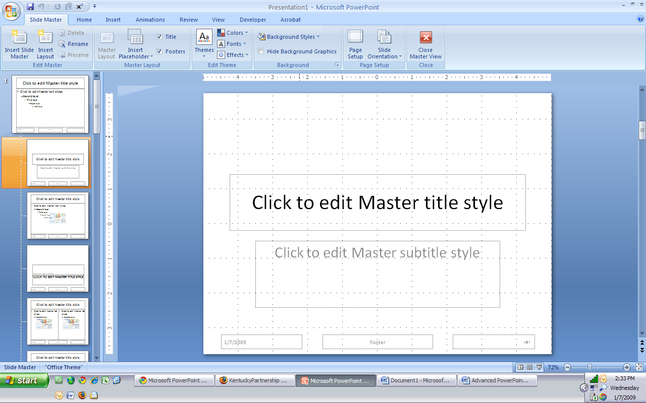

Formatting the Slide Master
The Crabby Lady in Microsoft Office online (yes, Microsoft has a sense of humor) says that the Slide Master is the interior decorator of PowerPoint. To view her full article on PowerPoint, go to www.office.microsoft.com and enter “Crabby Lady Demystifies PowerPoint Terms.”
Several suggested (not recommended) formatting sources:
- http://www.functionx.com/powerpoint/Lesson13.htm
- Google “PowerPoint Formatting”
When you have finished editing the Slide Master, click Close Master View to return to the presentation.

Saving a Slide Master as a template
The changes you make to the slide master can either be saved to your current presentation, or, you can save the slide master to be used again.
After you have made changes to the slide master, go to File → Save and in the Save as type option, choose:
Microsoft Office 2007 | Choose PowerPoint Template
You could create a custom template using the slide master for your company or organization. This will give all presentations the same, cohesive look!
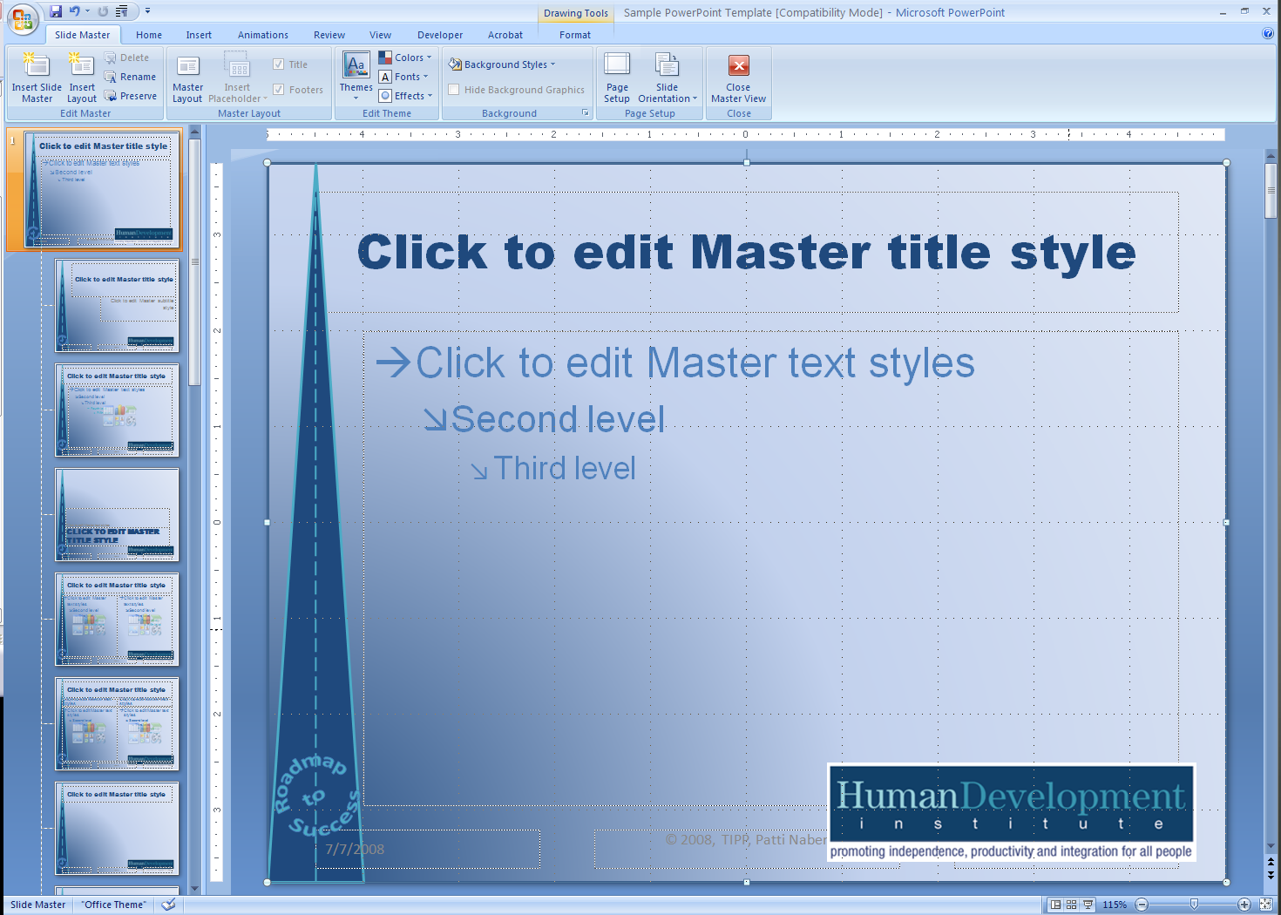
Company Logo
Name of training series
Same pattern as training series registration materials, handout, etc.
Same color, font as website

Creating Screenshots

What are screenshots?
- Still, digital image to be attached to a resource for illustration purposes
- Screen capture, screen dump. Image taken by the computer to record visible images to another device www.wikipedia.org
What can you do with a screenshot? (write-in):

Can I edit my screenshot?
You may edit a screenshot by cropping and resizing.
You are not able to change the content of the screenshot without using an advanced editing program such as Adobe Photoshop or Macromedia Fireworks. Other free products are also available online, though they offer fewer functions. These include Adobe Photoshop Online (www.photoshop.com) and Snapfish (www.snapfish.com). The products and websites listed are suggestions, not recommendations.

To ‘capture’ a screenshot
- Open the window, document, program you wish to use for the screenshot
- Hold the ALT key while pressing PrintScreen (PrtScn), which is typically located on the upper-right hand corner of your keyboard.
Some products allow to capture a screenshot by only clicking the PrintScreen key. You can try both.
- Go to the document, program you wish to ‘paste’ the image
- Paste using the Edit menu, or ctrl-p, or right-click then select Paste
The above instructions will work on most PC’s and in all programs. Some menu’s may not allow screenshots to be taken.
You can find out more information about using screenshots at www.about.com. Search for screenshots.
Screenshots may be edited/formatted using the Formatting tools in Word.

Custom Slide Show

What is a custom slide show?
A custom slide show gives the presenter the ability to narrow the slides shown during a presentation. There are several reasons why you would create a custom slide show (write-in):

How to create a custom slide show?

Microsoft Office 2007 | - Go to the Slide Show ribbon  - In the Start Slide Show section, choose Custom Slide Show > Custom Shows  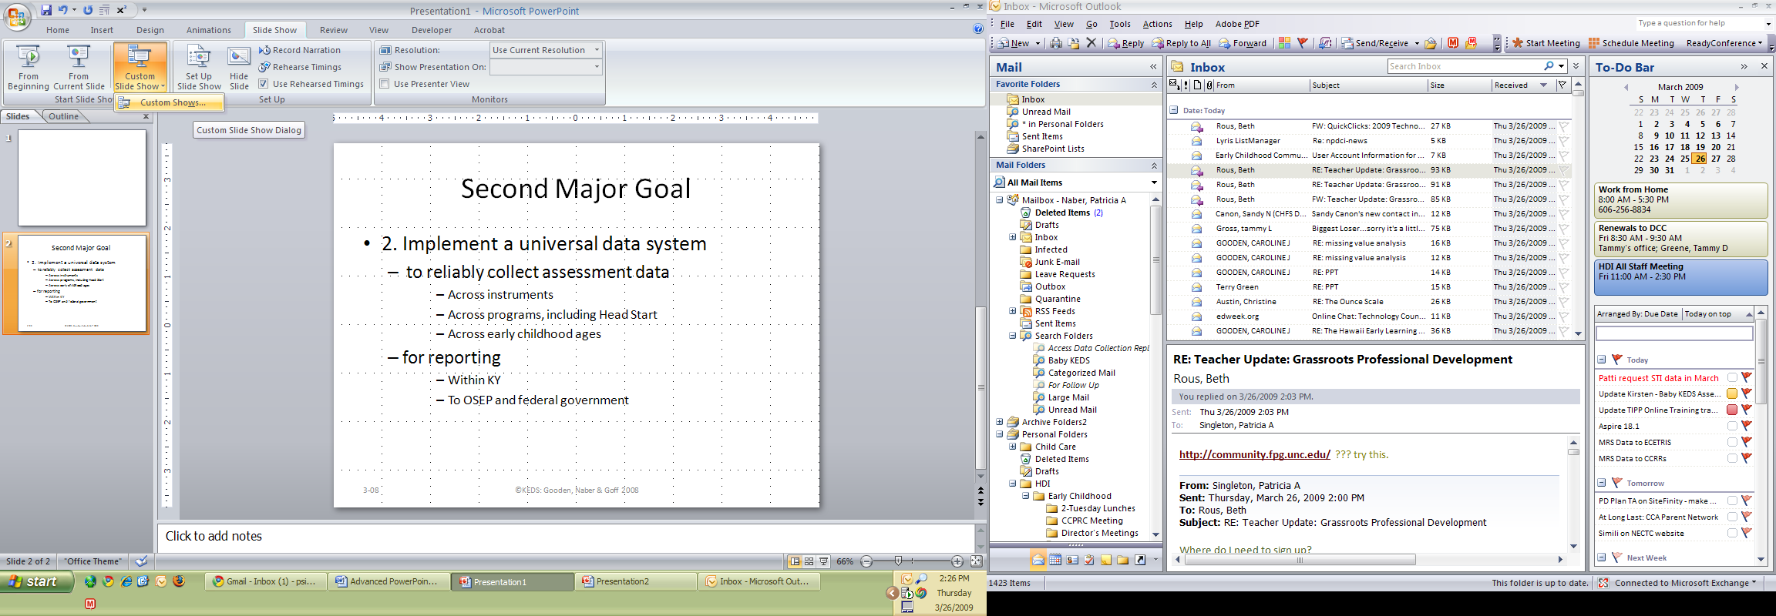

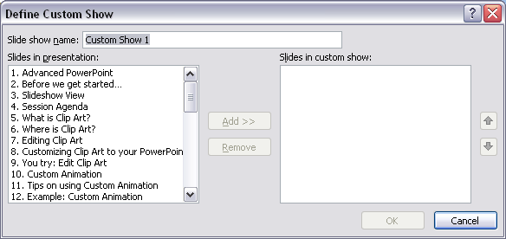
Once you have the Custom show window open,
- Click New to create a new custom slide show. The Define Custom Show window will appear.
- In the Slide show name: box, enter a name or description of the slide show.
- Under Slides in presentation:, select the slides you wish you add to your custom slide show.
- When you have added your slides, you may reorder the slides by selecting the up and down arrows. Remove slides you do not want to include in the custom slide show by selecting the slide and clicking Remove.
- When you have finished adding your slides, click Ok.

Opening a Custom Slide Show
Once a custom slide show has been created, return to the Custom Slide Show Menu. A list of the named slide shows will display. Choose the slide show you wish to view.
TIP – you can create a link in a PowerPoint presentation to a custom slide show. Refer to the Creating Linked Slides portion of this document.

Additional Notes:

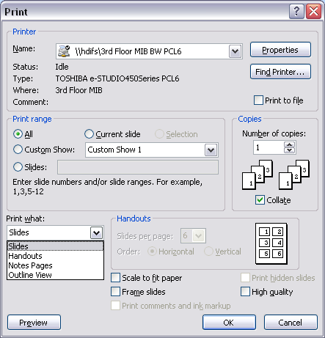
PowerPoint Printing Options

Print Range
  - All – prints all slides
  - Current slide – prints only the active/current slide
  - Custom Show – if custom show has been created
  - Slides – enter the slide number(s) of the slides you wish to print

Print What
  - Slides – prints 1-slide per page
  - Handouts – prints designated slide(s) per page
  - Notes Pages – prints 1-slide per page and notes
  - Outline View – prints continuous list of slides in outline format

Handouts
  - If Handouts is selected from Print What, the Handouts section will become active
  - Slides per page – Options are 1, 2, 3, 4, 6, 9
  - Order – Horizontal (rightàleft) or Vertical (upàdown)
Scale to fit paper
  - If using non-traditional sized paper (legal) or if graphics run over slide
Frame Slides
  - Inserts a frame (border) around the slide

Print hidden slides
  - If you have ‘hidden’ any slides in the presentation, will include these in printing
High Quality
  - Will print a better-quality handout
  - More ink, more time to print
  - Most printers are set to print ‘medium’ quality
Print Comments and ink Markup
  - If presentation has reviewer comments, will display in printing
Print Preview
  - Will display a preview of selected print options

Importing External PowerPoint Slides

What is importing external PowerPoint slides?

Reuse and Recycle! PowerPoint has built-in features which allows you to easily import PowerPoint slides from other presentations.
- What are the advantages?
  - Creating a library of slides
  - Share with co-workers
  - No more re-creating slides!
  - Less work!
  - What additional advantages are there (write-in):

How will I reuse PowerPoint slides?
Name one presentation where you will reuse slides when you return to your office:

PowerPoint Slide Library
PowerPoint also has a built-in slide library – a place to store a copy of all your PowerPoint slides.
- To save PowerPoint slides to the slide library – go to File à Publish à Publish Slides. You are able to select which slides you wish to save (or all of them), then specify the path for your slide library. If your office uses an internal server (e.g. SharePoint) there are additional options, allowing access to multiple users.
- For more information on using the slide library – click on the Help (F1) button and enter “slide library.”
Microsoft Office 2007 | - In the Home ribbon, look for the Slides group.  - Click the drop-down beside new slide and find the Reuse Slide option.  - A new window will appear in the right-hand side of the screen. Here, you can browse for the file(s) you wish to import slides from.  Browse is a drop-down menu that keeps a running list of your most recent PowerPoint presentations or allows you to open the Slide Library or Browse to a file.  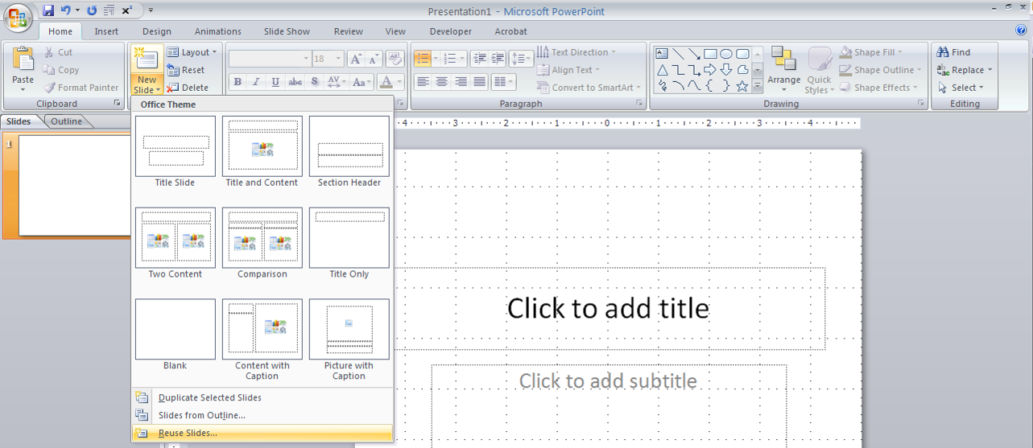  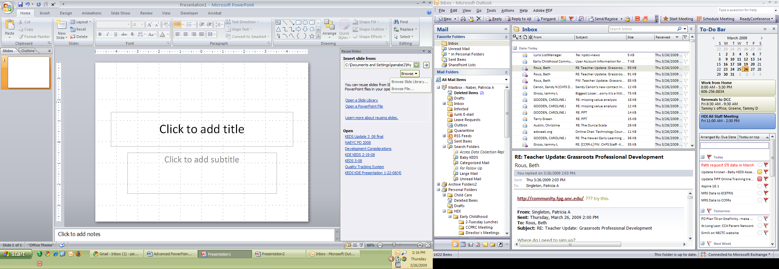  Once the Reuse Slides window is available on the right-hand side, you may select the slides you want to reuse, or use the select all option to import all of the slides.  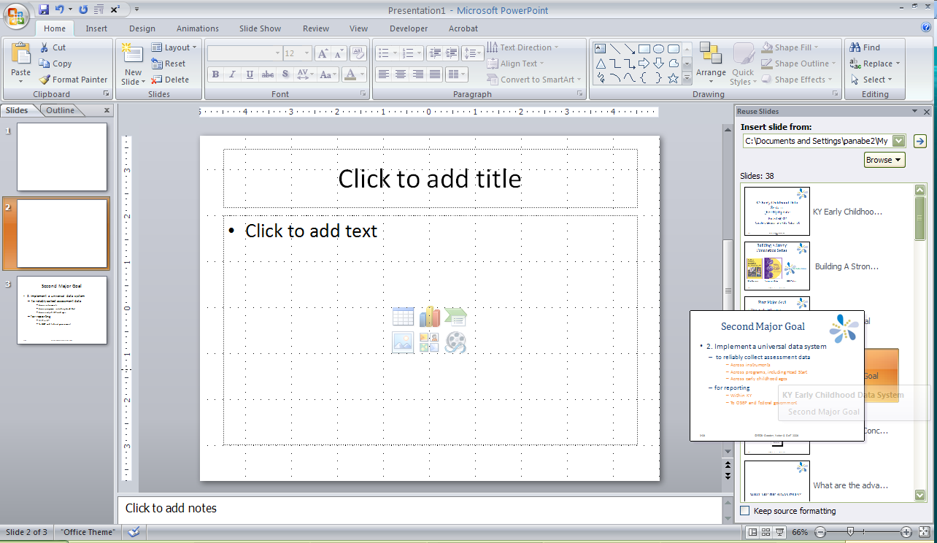

Source/Slide Formatting

After importing the slides, if you choose Keep Source Formatting, the inserted slide will keep its original formatting, including the original template. In the example below, there are three slides inserted, all with the original source formatting. You will see the template is different on all three slides.
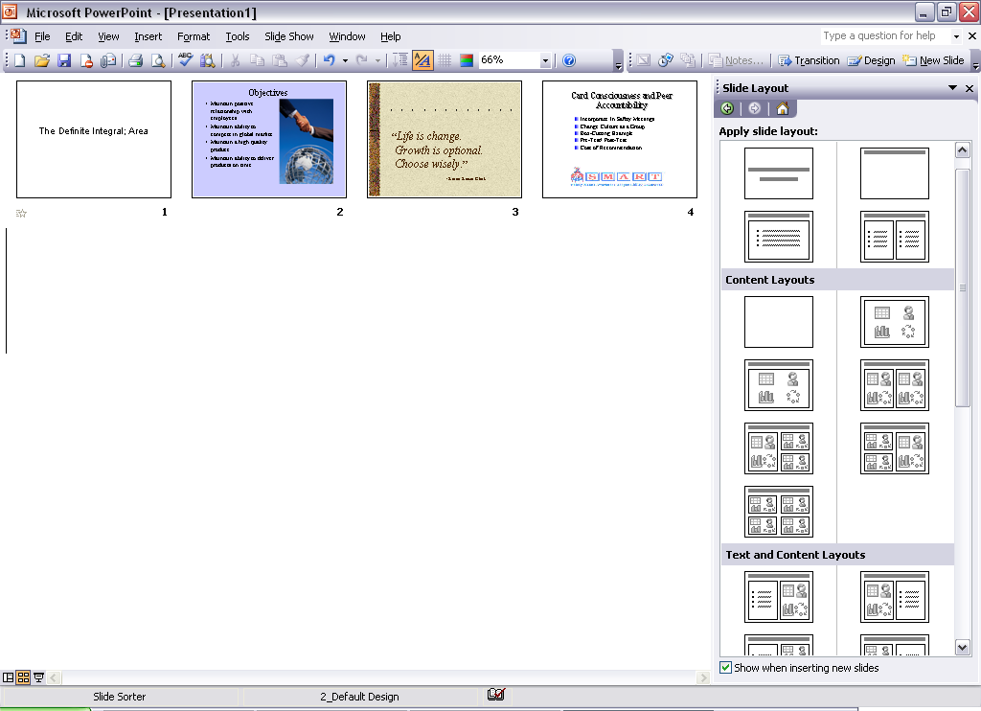

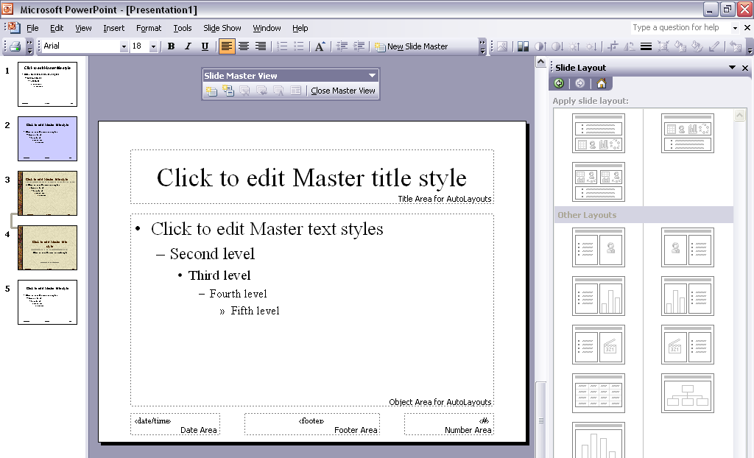
The addition of these slides has added several new Slide Masters. See a screenshot of the slide master screen below. You can see these slide masters all have different formatting.

Creating Linked Slides

What are linked slides?
Similar to how a web page uses links, you can insert links within your PowerPoint presentation to move among the slides.

How can I use linked slides?
- Agenda Slide
- Reference
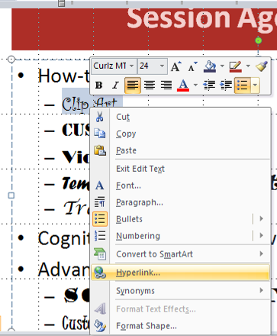
- Review
- Other (write in):

How to create a link within a slide?
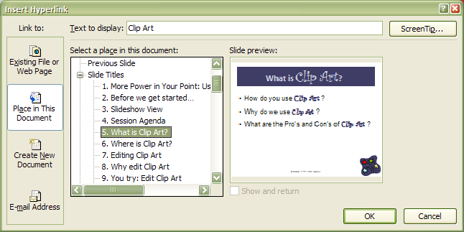
- Enter the text you wish to display as link
- Right click, select Hyperlink
- Choose Place in this Document
- Can be a slide or a custom show
How will you use linked slides? (write-in)

Other Links

Hyperlink
To create a hyperlink within PowerPoint (or any other Microsoft Document) to a website:
- Copy the web address
- Go to the address bar, which begins with http://...
- Click once to highlight
- With the address still highlighted, right-click and select copy or click ctrl-C
- In the PowerPoint presentation, Paste the web address.
- If the hyperlink does not turn blue – hit the space bar at the end of the address
- Highlight the blue link. Right-click and select Edit Hyperlink.
- In the Text to Display box, the web address will appear. Clear the address and enter the wording that you want to become the hyperlink text. In the example in the presentation, only www.kentuckypartership.org/tipp displays on the slide. However, if you edit the hyperlink, you will see the link is to http://www.kentuckypartnership.org/tipp.

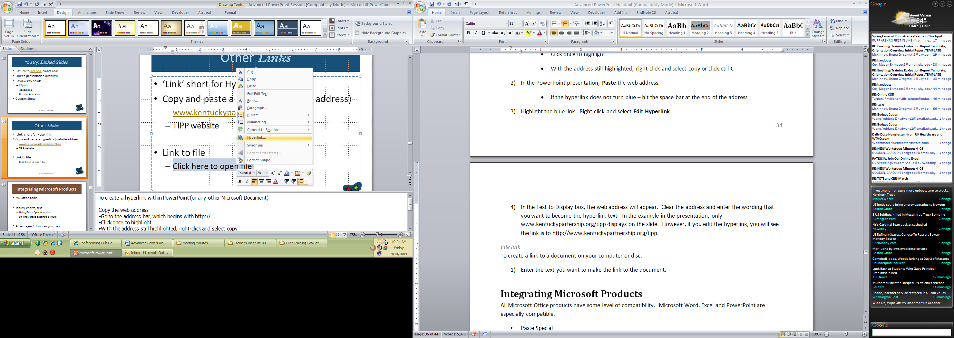
File link
To create a link to a document on your computer or disc:
- Enter the text you want to make the link to the document.
- Right-click and select Hyperlink
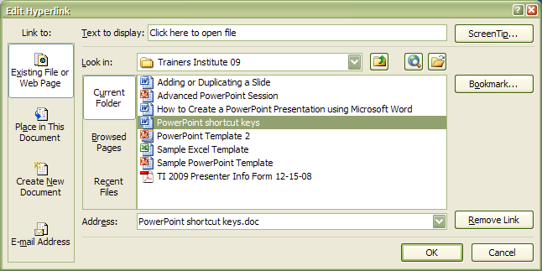
- Select Existing File or Webpage
- Find the file you wish to link to. The example in the presentation is a link to the Microsoft Shortcut Keys file.

Integrating Microsoft Products
All Microsoft Office products have some level of compatibility. Microsoft Word, Excel and PowerPoint are especially compatible.

To insert an Excel Workbook object
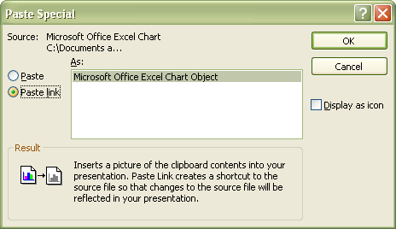
- Copy the Excel object (chart, table, data) you wish to paste in PowerPoint
- Use the Paste Special function
  - Paste picture
  - Insert link
- Insert Link
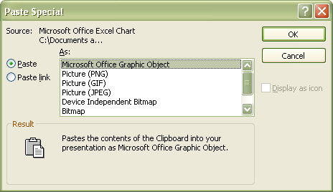
  - Microsoft Excel object will update if the data in your Excel changes.
- Picture or Graphic
  - Object will be static, will not change if data is updated

To create a chart or table within PowerPoint
- In PowerPoint, click on the Insert or ribbon (2007)
- Select Chart
- A new window, “Insert Chart” will appear.
- Select the chart type you wish to add.
- An Excel spreadsheet will open. Example data is provided. You are able to clear the example data, and insert the data you wish to use in your chart.
- When you have finished adding your data, close the Excel spreadsheet (you do not have to save).
- The chart will now display with your data. Should you need to edit the chart or the data, click on the chart. A tool tab, Chart, will become visible. You are able to access these same options by right-clicking on the chart.

Practice pasting Excel objects
Saved on your disk is an Excel spreadsheet named Advanced PowerPoint Excel Spreadsheet. Open this file.
1) Copy (ctrl-c) the chart in Excel
2) Return to the PowerPoint.
Microsoft Office 2007 | In the Home ribbon, go to the Clipboard group, select the drop-down below Paste > Paste Special  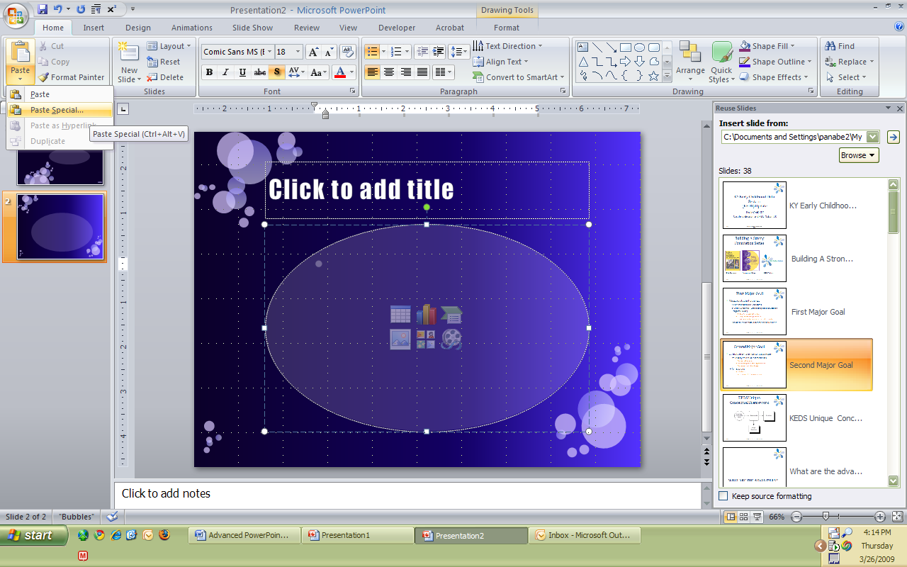

Paste Options:
- Link to Excel
- Paste Excel spreadsheet
- Insert as a graphic
Warning: PowerPoint is now reading data from that spreadsheet. Moving or renaming the Excel spreadsheet can cause it to break this link.
If you are storing the spreadsheet on a portable device (CD, disk), consider creating a copy onto that disk. You may break the link, right click on the chart/ table/ text and select Linked Workbook Object à Convert à Select picture option.

Additional Notes

PowerPoint Games
- Interactive activity embedded in presentation
- Resources
  - www.google.com Search for PowerPoint Games
  - https://www.lifewire.com/free-powerpoint-games-for-teachers-1358169

PowerPoint Viewer
- PowerPoint Viewer 2003
  - View full-featured presentations
  - www.microsoft.com
    - Search for “PowerPoint Viewer 2003”
  - Save file to disk to ensure you always have handy
- Able to view and print PowerPoint presentations.
- Not able to edit PowerPoint presentations.
- Other Microsoft viewer programs available through Microsoft.com (Word, Excel).

Other Presentation Software
- Google Docs
  - Free
  - Less features
  - http://docs.google.com
- Corel Presentations
  - WordPerfect Suite
  - www.corel.com
- Be aware: the standard presentation software is Microsoft PowerPoint. Should you use any product other than PowerPoint, you may have to save in a different format to access on another computer.

Save Options

Save to CD
  - Create and Save PowerPoint. Find the folder where the PowerPoint is saved. Right-click, select Send To à CD. A balloon will appear that says “You have files waiting to be written to CD.” Click this balloon, and then click “Write files to CD.”

Save as PDF

View Presentation as PDF
Save PowerPoint as Adobe Portable Document Format (PDF).
  - Open PDF
  - Select View à Full Screen Mode
  - Use arrow keys to move through slides.
  - The PowerPoint from today’s presentation is saved as a PDF on the CD. Open and view.

Downloading Adobe PDF to your computer
www.adobe.com/reader Look for the Download button. As of April 2009, the most recent version of Adobe reader was 9.1.

Citations in PowerPoint
When referencing work not your own, you should include the original source.

Where can I find information about citations
  - American Psychological Association http://apastyle.apa.org
  - Google “APA Style” for additional resources

Copyright Resources

US Copyright Office www.copyright.gov
The Art of Presenting a good Presentation

What a Good Presentation Looks Like
Looks good projected.
- Not just on your computer!
- High contrast is best
Is organized.
  - Use bullets to organize points
    - Avoid using paragraphs.
  - One idea per slide.
Is visual.
  - Don’t overload with cool features!
x
  - No more than 2 text slides in a row.
  - Rule of “6”

Other visual aids in the age of PowerPoint
- Clip art, pictures
- Graphs, charts
- Cartoons
- Quotations
- Video

Choosing the Right Colors

- Use the color wheel.
- Choose complimentary colors
- Look for contrast
  - Stay away from bright colors.
  - Choose the right colors for your PowerPoint Presentation

Index

activity, 30
Adobe Portable Document Format, 31
Adobe Portable Document Format (PDF), 31
Agenda Slide, 26
animation, 7
APA Style, 31

bullets, 32

Chart, 28
Citations, 31
Clip Art, 7, 9, 11
clip art library, 7
color wheel, 32
contrast, 32
Copyright, 8, 31
Custom Animation, 12
custom template, 18

Drawing Tools, 10

edit clip art, 9
Excel spreadsheet, 28
Excel Spreadsheet, 28

hyperlink, 26
Hyperlink, 26

Keep Source Formatting, 25

library, 7, 19, 23
linked slides, 26
Linked Workbook Object, 29

Media Clips, 14
Microsoft Word, 27

Paste Special, 27
PDF, 31
Picture Format, 10
Picture Menu, 10
PowerPoint Games, 30
PowerPoint Viewer, 30

Shortcut, 4
slide library, 23
slide master, 15
Slide Master, 17, 18

template, 15, 17, 18, 25
theme, 15

video clip, 14
video clips, 13
Viewer, 30
visual aids, 32

? Items with two lines of keys indicate two separate commands for the same action.
http://www.netnet.org/instructors/coursedev/itvcourse/graphics.htm
http://www.netnet.org/instructors/coursedev/general.htm#rule20

